

UNITED STATES
SECURITIES AND EXCHANGE COMMISSION
Washington, D.C. 20549

FORM 10-K

(Mark One)

ANNUAL REPORT PURSUANT TO SECTION 13 OR 15(d) OF THE SECURITIES EXCHANGE ACT OF 1934
For the fiscal year ended December 31, 2023

OR

TRANSITION REPORT PURSUANT TO SECTION 13 OR 15(d) OF THE SECURITIES EXCHANGE
ACT OF 1934 FOR THE TRANSITION PERIOD FROM TO

Commission File Number 000-50658

Marchex, Inc.
(Exact name of Registrant as specified in its Charter)

Delaware |  | 35-2194038
(State or other jurisdiction of |  | (I.R.S Employer
incorporation or organization) |  | Identification No.)
1200 5th Ave., Suite 1300, | 98101
Seattle, Washington
(Address of principal executive offices) |  | (Zip Code)

Registrant’s telephone number, including area code: (206) 331-3300

Securities registered pursuant to Section 12(b) of the Act:

Title of each class |  | Trading Symbol(s) |  | Name of each exchange on which registered
Class B Common Stock, $0.01 par value per share |  | MCHX |  | The NASDAQ Stock Market LLC
 |  |  |  | (NASDAQ Global Select Market)
Securities registered pursuant to Section 12(g) of the Act: None
Indicate by check mark if the Registrant is a well-known seasoned issuer, as defined in Rule 405 of the Securities Act. |  |  |  |  | YES | NO
Indicate by check mark if the Registrant is not required to file reports pursuant to Section 13 or Section 15(d) of the Act. |  |  |  |  | YES | NO

Indicate by check mark whether the Registrant (1) has filed all reports required to be filed by Section 13 or 15(d) of the Securities Exchange Act of 1934 during the preceding 12 months (or for such shorter period that the Registrant was required to file such reports), and (2) has been subject
to such filing requirements for the past 90 days. YES NO

Indicate by check mark whether the Registrant has submitted electronically every Interactive Data File required to be submitted pursuant to Rule 405 of Regulation S-T (§232.405 of this chapter) during the preceding 12 months (or for such shorter period that the Registrant was required to
submit such files). YES NO

Indicate by check mark whether the registrant is a large accelerated filer, an accelerated filer, a non-accelerated filer, smaller reporting company, or an emerging growth company. See the definitions of “large accelerated filer,” “accelerated filer,” “smaller reporting company,” and “emerging growth company” in Rule 12b-2 of the Exchange Act.

Large accelerated filer

Non-accelerated filer

Emerging growth company

Accelerated filer
Smaller reporting company

If an emerging growth company, indicate by check mark if the Registrant has elected not to use the extended transition period or complying with any new or revised financial accounting standards provided pursuant to Section 13(a) of the Exchange Act.

Indicate by check mark whether the registrant has filed a report on and attestation to its management’s assessment of the effectiveness of its internal control over financial reporting under Section 404(b) of the Sarbanes-Oxley Act (15 U.S.C. 7262(b)) by the registered public accounting
firm that prepared or issued its audit report.

If securities are registered pursuant to Section 12(b) of the Act, indicate by check mark whether the financial statements of the registrant included in the filing reflect the correction of an error to previously issued financial statements.

Indicate by check mark whether any of those error corrections are restatements that required a recovery analysis of incentive-based compensation received by any of the registrant’s executive officers during the relevant recovery period pursuant to §240.10D-1(b).

Indicate by check mark whether the Registrant is a shell company (as defined in Rule 12b-2 of the Exchange Act). YES NO

The aggregate market value of the voting and non-voting common equity held by non-affiliates of the Registrant, based on the closing price of the shares of Class B common stock on The NASDAQ Stock Market on June 30, 2023 was $46,156,094.

The number of shares of Registrant’s Class A common stock outstanding as of March 25, 2024 was 4,660,927. The number of shares of Registrant’s Class B common stock outstanding as of March 25, 2024 was 38,997,668.

Portions of the Registrant’s Definitive Proxy Statement relating to the 2024 Annual Meeting of Stockholders are incorporated herein by reference in Part III of this Annual Report on Form 10-K to the extent stated herein.

TABLE OF CONTENTS

 |  | Page
 | Part I
ITEM 1. | BUSINESS | 4
ITEM 1A. | RISK FACTORS | 10
ITEM 1B. | UNRESOLVED STAFF COMMENTS | 24
ITEM 1C. | CYBERSECURITY | 24
ITEM 2. | PROPERTIES | 24
ITEM 3. | LEGAL PROCEEDINGS | 24
ITEM 4. | MINE SAFETY DISCLOSURES | 24
 | Part II
ITEM 5. | MARKET FOR REGISTRANT’S COMMON EQUITY, RELATED STOCKHOLDER
 | MATTERS AND ISSUER PURCHASES OF EQUITY SECURITIES | 25
ITEM 6. | SELECTED FINANCIAL DATA | 25
ITEM 7. | MANAGEMENT’S DISCUSSION AND ANALYSIS OF FINANCIAL CONDITION AND
 | RESULTS OF OPERATIONS | 26
ITEM 7A. | QUANTITATIVE AND QUALITATIVE DISCLOSURES ABOUT MARKET RISK | 35
ITEM 8. | FINANCIAL STATEMENTS AND SUPPLEMENTARY DATA | 36
ITEM 9. | CHANGES IN AND DISAGREEMENTS WITH ACCOUNTANTS ON ACCOUNTING AND
 | FINANCIAL DISCLOSURE | 61
ITEM 9A. | CONTROLS AND PROCEDURES | 61
ITEM 9B. | OTHER INFORMATION | 61
 | Part III
ITEM 10. | DIRECTORS, EXECUTIVE OFFICERS AND CORPORATE GOVERNANCE | 63
ITEM 11. | EXECUTIVE COMPENSATION | 63
ITEM 12. | SECURITY OWNERSHIP OF CERTAIN BENEFICIAL OWNERS AND MANAGEMENT
 | AND RELATED STOCKHOLDER MATTERS | 63
ITEM 13. | CERTAIN RELATIONSHIPS AND RELATED TRANSACTIONS, AND DIRECTOR
 | INDEPENDENCE | 63
ITEM 14. | PRINCIPAL ACCOUNTING FEES AND SERVICES | 63
 | Part IV
ITEM 15. | EXHIBITS, FINANCIAL STATEMENT SCHEDULES | 64

2

FORWARD-LOOKING STATEMENTS

This Annual Report on Form 10-K contains forward-looking statements within the meaning of Section 27A of the Securities Act of 1933, as amended, and Section 21E of the Securities Exchange Act of 1934, as amended. We use words such as “believes”, “intends”, “expects”, “anticipates”, “plans”, “may”, “will” and similar expressions to identify forward-looking statements. All forward-looking statements, including, but not limited to, statements regarding our future operating results, financial position, prospects, acquisitions, dispositions, and business strategy, expectations regarding our growth and the growth of the industry in which we operate, and plans and objectives of management for future operations, are inherently uncertain as they are based on our expectations and assumptions concerning future events. We may not actually achieve the plans, intentions or expectations disclosed in our forward-looking statements we make. There are a number of important factors that could cause the actual results of Marchex to differ materially from those indicated by such forward-looking statements. Any or all of our forward-looking statements in this report may turn out to be inaccurate. We have based these forward-looking statements largely on our current expectations and projections about future events and financial trends that we believe may affect our financial condition, results of operations, business strategy and financial needs. They may be affected by inaccurate assumptions we might make or by known or unknown risks and uncertainties, including the risks, uncertainties and assumptions described in Item 1A of this Annual Report on Form 10-K under the caption “Risk Factors” and elsewhere in this report, and those described from time to time in our future reports filed with the SEC. In light of these risks, uncertainties and assumptions, the forward-looking events and circumstances discussed in this report may not occur as contemplated, and actual results could differ materially from those anticipated or implied by the forward-looking statements. All forward-looking statements in this report are made as of the date hereof, based on information available to us as of the date hereof, and we assume no obligation to update any forward-looking statement.

3

PART 1

ITEM 1. BUSINESS

Overview

References herein to “we,” “us” or “our” refer to Marchex, Inc. (“Marchex” or the “Company”) and its wholly-owned subsidiaries unless the context specifically states or implies otherwise.

Marchex harnesses the power of AI and omnichannel conversational intelligence to provide actionable insights aligned with prescriptive vertical market data analytics, driving operational excellence and revenue acceleration. Marchex enables executive, sales, and marketing teams to optimize customer journey experiences across communications channels. Through our prescriptive analytics solutions, we enable the alignment of enterprise strategy, empowering businesses to increase revenue through informed decision-making and strategic execution. Marchex provides conversational intelligence AI-powered solutions for market-leading companies in leading B2B2C vertical markets, including several of the world’s most innovative and successful brands.

Our mission is to create intelligence around all types of business conversations. We desire to be a leader in vertical market conversational intelligence leveraging generative artificial intelligence and data analytics. We seek to empower performance improvements for our customers by giving them actionable, real-time insights into the conversations they are having with their customers across phone, text and other communication channels. We have assembled a set of applications that incorporate artificial intelligence (“AI”) functionality for enterprises that depend on phone calls, texts and other communication channels to help convert prospects into customers, enabling compelling customer experiences during the sales process and helping maximize returns. Our proprietary data and conversational insights help enable brands to personalize customer interactions in order to accelerate sales and capture more opportunities to grow their business. We serve large enterprises with a distributed footprint that interact with their customers across multiple communication paths.

We operate primarily in U.S. domestic markets with desires to move into other markets over time. Our leveraging of generative AI is an active approach and allows the understanding of interactions without a human needing to converse, type or interpret. Our conversational intelligence product offerings are:

Marketing Edge. Marketing Edge leverages conversational intelligence with generative AI to form a comprehensive marketing attribution and conversation data solution. The platform identifies which campaigns and channels are driving inbound conversations, evaluates what happens during those conversations, and closes the sales loop by connecting converted sales to marketing driven leads. Through optimization and advanced tracking, Marketing Edge enables customers to improve marketing, validate budgets, and drive revenue acceleration and operational excellence. Marketing Edge received the 2022 Business Intelligence Group’s ("BIG") Sales And Marketing Technology Award.

Sonar Business Text Messaging. Sonar Business Text Messaging is an AI empowered, intelligent workflow enabled mobile messaging solution that enables operations, sales and marketing teams to
communicate personally with field staff, prospects and basic text messaging, it provides a comprehensive and flexible two-way messaging solution that uses AI-powered automation to augment field-facing and customer-facing staff, driving dramatic and measurable increases in critical actions, customer engagement and conversions. The offering encompasses a unique workflow system that allows the conversations to be connected to the client journey.

4

Marchex Platform Services. Marchex Platform Services is a robust API-based, conversation intelligence product that allows executives, sales, customer engagement and marketing teams to apply Marchex AI to most any calls, regardless of communication platform, in order to identify actionable insights from conversations with their customers. This allows an active understanding of the conversations occurring. The platform allows a business to send phone call audio recordings directly from their existing communications platforms to Marchex and in turn receive actionable conversation insights such as call outcome, industry-specific deep call analysis, and speech-to-text transcripts, enabling data-driven decision-making, enhanced customer experiences, and improved sales outcomes. In 2023, Marchex launched new features such as AI-generated Call Summaries and Sentiment Suite that are available via Marchex Platform Services. These new features analyze and generate summaries of consumer-to-business calls, enabling businesses to immediately identify customers who have had exceptionally good experiences, as well as dissatisfied customers. They leverage the power of generative AI to help transform the way businesses can capture and utilize critical insights from customer interactions, as well as combine structured and unstructured data to provide a holistic view of customer emotions during conversations. Marchex Platform Services earned the 2022 BIG New Product Award.

Spotlight. Spotlight is an innovative AI conversation analytics product that has been specifically designed for multi-location businesses. Trusted by top brands and used by thousands of multi-location rooftops, the product provides critical insights and delivers actionable, data-driven observations that help enterprises improve performance across their national and regional sales Spotlight, corporate and regional managers can easily identify and track top-performing locations, as well as those that may be underperforming. Armed with this information, managers can make informed decisions to improve call handling and improve outcomes, leading to increased revenue and brand loyalty. Spotlight was named “Product of the Year” as part of the 2023 BIG Awards for Business.

Engage. Engage is a comprehensive solution that provides locations with applications to enhance their overall performance. With a keen focus on call handling and outcomes, it helps improve customer
satisfaction ratings, increase appointment set rates, and drive incremental solution integrates call data into the business’s CRM to capture all customer interactions in one place, providing valuable insights for optimization as well as real time alerts when a sales conversation ends negatively, creating opportunities for training, accountability and empowering revenue growth. Overall, Marchex sales engagement technology is recognized as an industry leader, winning the 2023 Conversation DNA - Automation Category from AI Excellence Awards. Engage was also named "Best AI-Based Solution for Sales” by AI Breakthrough in 2023.

Key Trends Driving our Industry and Business

Understanding calls and/or texts is highly complex. Unlike clicks, impressions and other actions that are tracked and measured in digital format, calls and text messages require unique technical capabilities and expertise to accurately measure and analyze. To realize the full benefit of call and/or text-based marketing, customers need technology that allows them to capture and analyze attributes of a call and/or text before, during and after the call and/or text is completed. This technology can connect a conversation from a placed advertisement through the interaction with a business, often with individual sales representatives, to understand the effectiveness of the marketing action. This can help better measure return on investment (“ROI”) and optimize marketing campaigns across media channels. For example, customers want to be able to dynamically track the source of a call back to the media channels and advertisements that influenced the consumer to make the call. Once a call is initiated, technology is required to understand what is happening on a call, to record anonymized calls, and to block unwanted or spam calls. For many of Marchex’s customers calls are often tracked and routed through interactive voice response (“IVR”) phone systems and integrated with customer relationship management (“CRM”) applications and back-office systems to measure transactions and ROI. Successful marketing analytics for calls and texts requires expertise from multiple disciplines, including digital advertising, communications infrastructure, voice and speech recognition expertise, and marketing software.

5

Mobile phone growth has changed the way customers and businesses interact. The majority of the world’s population now utilizes mobile phones and mobile phone usage is expected to continue to grow as the primary consumer communication device for the foreseeable future. According a 2022 study published by ConsumerAffairs, 97% of the population in the United States has a mobile phone. According to a 2023 eMarketer study, consumers are spending more time on their mobile connected devices than in front of televisions, a trend that is forecasted to grow. According to MarketingCharts, two of the top uses of mobile phones among consumers are texting/messaging and calling. We believe it is critical for many businesses to develop strategies to understand their consumer engagement across multiple communication channels as consumers seamlessly shift between different forms of communication during the buying process.

For many businesses, calls and texts are critical to drive sales. For businesses of all sizes, in-bound phone calls can be a key source of new customer leads and increased revenue. We believe consumers that call or text businesses directly typically have higher purchase intent and can be more likely to make a purchase or become a customer. According to an independent research study by Forrester Consulting, the study found that phone customers convert faster, spend more, and have a higher retention rate than customers who contact brands through other channels. Based on a survey of marketing decision makers, the study found that that 60% of marketers said that those who initiate an inbound call in the course of the customer journey convert an average of 30% faster and spend an average of 28% more; 54% of marketers said that customers who initiate an inbound call have a 28% higher retention rate. In addition, according to MessageDesk, 77% of consumers prefer to talk to someone over other means of communication such as a chatbot. Calls and texts can be particularly relevant in high-value categories, such as automotive, home services, auto services, and healthcare where transaction values are large, complex or require additional information prior to completion. Calls and texts are also important for local businesses that set appointments or sell products and services over the phone.

Market for conversational intelligence. As customers continue to shift their budgets to accommodate for the growth of mobile channels, we believe the market for conversational analytics will grow even more. In fact, the phone call has become the most popular engagement channel for a majority of U.S. customers, leapfrogging email over the past two years, according to Salesforce’s State of the Connected Customer report, with 59% of consumers preferring to engage businesses over the phone. Calls and texts are two of the primary consumer communication methods with businesses on mobile devices and building solutions to help businesses understand their consumer interactions through these communication channels can help businesses engage and grow.

Highly competitive market. The market for our service offerings is highly competitive, rapidly evolving, and subject to changing technology and shifting customer needs. We compete with conversation analytics providers such as Twilio, EZ Texting, CallSource, CallRail, and Invoca. As we advance our data analytics technologies, the competitive landscape will increase and become broader.

Seasonality. Historically, our industry has experienced seasonality and we believe that it will continue to do so. Our experience has shown that during the spring and summer months, call volumes in certain verticals such as home services are generally higher than during other times of the year. Further, during the latter part of the fourth quarter of the calendar year we generally experience lower call volumes.

Our Strategy and Competitive Strengths

OneStack. We anticipate achieving operating and cost efficiencies by migrating all primary software stacks, clouds and data centers into one environment, or OneStack, which we believe will further enhance our strategic competitiveness and help drive acceleration of our AI product initiatives and future innovation. OneStack enables our technologies, products and clients to be more easily managed in a unified operating environment and provides a streamlined go to market approach, allowing our vertical market clients to consume all our signals, data analytics and applied AI and also provides speed and scale for client onboarding while streamlining support and account management.

6

Innovating on conversational intelligence technology and solutions. We desire to normalize all conversational channels and leverage generative AI for understanding with scale and speed. The ability to interpret most any conversation through any potential channel and provide action to insight in real time adds value to our clients for revenue acceleration. We plan to continue to expand and invest in our conversational intelligence technology and expand our AI, data science and machine learning capabilities. Marchex’s large base of conversational data assets give it a unique advantage to continue to innovate with data science and AI to help our customers sell more and deliver a better customer experience across communication channels. We plan to continue to expand our use of Generative AI large language models to supplement our innovation and deliver new products as well as additional insights and features throughout our product portfolio and roadmap. We plan to continue to expand our range of call, text, and other communication channels analytics and sales engagement product capabilities by growing our conversational intelligence solutions, including AI-driven speech technology solutions, call tracking, call monitoring, text communications, keyword-level tracking, display ad impression measurement and other products as part of our owned, end-to-end, call and text-based solutions. Our expanding capabilities are enabling us to develop new solutions, such as sales engagement, personalization solutions and performance measurement that enable us to take advantage of our growing conversational data assets.

Expanding our vertical markets and channel partners. We plan to continue investing in technology initiatives like Marchex Platform Services, which we believe will enable us to access a wide base of businesses by offering our products to a new array of channel partners across vertical markets. Through these initiatives Marchex can integrate with our customers' existing communication providers, telephony infrastructure providers, or customer relationship management software systems to offer our products and services. This opens a new opportunity to reach potential business that may desire access to Marchex vertical market insights while keeping their existing telephone infrastructure in place. Increasingly, Marchex customers will no longer need to access separate telephony infrastructure to engage with our conversational intelligence suite of products but, instead, will be able to choose to access our products from within their existing communications provider of choice.

Pursuing selective acquisition opportunities. We have historically and in the future may pursue select acquisition opportunities and will apply evaluation criteria to any acquisitions we may pursue in order to enhance our strategic position, strengthen our financial profile, and increase shareholder value.

Deep expertise in calls and texts. As consumer usage and mobile performance advertising has grown over the last decade, it is driving growth in customer interactions through calls and texts. As one of the first companies to help businesses utilize data driven insights and analytics to accelerate sales from phone conversations, we have developed solutions which can deliver measurable return on investment to both large national brands and local small businesses through connecting their offline phone conversations to their online marketing initiatives and offering sales acceleration solutions to help them create a better customer experience and grow sales. Working closely with our business clients, we have innovated in conversational intelligence technology, creating specific solutions to address common needs and wants among both large enterprises and small businesses.

Transparent pricing model. Marchex generally charges based on the number of conversations, either by call or text, that occur between a business and its customers, which it processes on behalf of the business. This enables businesses to adopt Marchex products through a transparent model that scales as a customer’s usage increases and may include a minimum commitment. As a result, we can provide a measurable return on investment for our customers.

Scalable technology platform and business model. We have developed our technology platform to address large customers, while also being able to support a large number of small local businesses. Our platform can support hundreds of millions of calls and thousands of unique customer accounts.

Sales, Marketing & Business Development

Our go to market approach is leveraging the alignment around OneStack. Our sales team focuses on adding new customers to our business and growing existing customer relationships, while our business development and partnership activities focus on adding new customers, reseller partnerships and servicing existing partnerships. Our marketing team focuses on promoting our services through online customer acquisition, affiliate relationships, press coverage, strategic marketing campaigns and industry exposure. Advertising and promotion of our services is broken into the following main categories:

7

Direct Sales. Our direct sales team targets new relationships with national and global customers through in-person presentations, direct marketing, telesales and attendance at industry events, among other methods.

Technology Integration Partnerships and Referral Agreements. We have integration partnerships with Adobe, Google, Salesforce, Customer Relationship Management software providers, and other third-party channel partners. We also have referral agreements with entities that promote our services to large numbers of potential customers including select technology partners.

Reseller Partnerships. We have a business development team which seeks to develop partnerships with large reseller partners.

We intend to continue our strategy of increasing our customer base through sales and marketing programs while being efficient in terms of our marketing and advertising costs. We continually evaluate our marketing and advertising strategies to optimize the effectiveness of our programs and their return on investment.

Information Technology and Systems

We have a proprietary technology platform for the purposes of managing and delivering conversational analytics and texting products and services to our partners. We also combine third-party licenses and hardware to create an operating environment for delivering high quality products and services, with such features as automated online account creation and management process for customers, real-time customer support, and interactive and online reporting for customers and partners. We also employ commercially available technologies and products distributed by various companies.

Our technology platform is compatible with many systems used by our customers, enabling us to deliver call analytics and texting products and services through mobile, online and offline sources in rapid response to user queries made through our customers at scale. We continue to build and innovate additional functionality to attempt to meet the quickly evolving demands of the marketplace. In order to maintain service availability, we primarily rely upon third parties to provide hosting services, including hardware support and service, and network monitoring at various domestic and international locations. Our servers and cloud-based services are configured for high availability and large volumes of call, mobile and texting based traffic and are located in leased third party facilities or deployed through cloud-based solution providers. Back-end databases make use of redundant servers and data storage arrays. We also have standby servers that provide additional capacity as necessary.

We continuously review ways to improve major aspects of our technology support and maintenance, including improving, upgrading, and implementing business continuity plans, data retention initiatives, and backup and recovery processes.

Intellectual Property and Proprietary Rights

We maintain a number of patents in the U.S. and other jurisdictions relating to various aspects of our technology. In addition to our patent portfolio, we have assembled, over time, an international portfolio of trademarks that covers certain of our products and services. We regularly analyze our patent and trademark portfolios and prepare additional patent applications on current and anticipated features of our technology and trademark applications for new product and service names, or abandon patents, trademarks or applications that are no longer relevant or valuable to our operations.

Our ability to compete across our businesses partly depends on the superiority, uniqueness, and value of the technology that we develop. To protect our proprietary rights, we rely on a combination of patent, trademark, copyright and trade secret laws, confidentiality agreements with our employees and third parties, and protective contractual provisions. These efforts to protect our intellectual property rights may not be effective in preventing misappropriation of our technology or may not prevent the development and design by others of products or technologies similar to or competitive with those we develop.

8

Employees

As of December 31, 2023, we employed a total of 164 full-time employees. We have never had a work stoppage and none of our employees are represented by a labor union. We consider our employee relationships to be positive.

Web site

Our web site, www.marchex.com, provides access, without charge, to our annual report on Form 10-K, quarterly reports on Form 10-Q, current reports on Form 8-K, and all amendments to those reports as soon as reasonably practicable after such materials are electronically filed with the Securities and Exchange Commission. To view these filings, please go to our web site and click on “Investor Relations” and then click on “SEC Filings.” Investors and others should note that we announce material financial information to our investors using our investor relations website, press releases, SEC filings, and public conference calls and webcasts. We also use the following social media channels as a means of disclosing information about us, our services, and other matters, and for complying with our disclosure obligations under Regulation FD:

Marchex X (formally known as Twitter) Account (https://twitter.com/marchex)

Marchex Company Blog (https://www.marchex.com/blog/)

Marchex LinkedIn Account (https://linkedin.com/company/marchex)

The information we post through these social media channels may be deemed material. Accordingly, investors should monitor the above account and the blog, in addition to following our investor relations website, press releases, SEC filings, and public conference calls and webcasts. This list may be updated from time to time. The information we post through these channels is not a part of this Annual Report on Form 10-K.

9

ITEM 1A. RISK FACTORS

An investment in our Class B common stock involves various risks, including those mentioned below and those that are discussed from time to time in our other periodic filings with the SEC. Investors should carefully consider these risks, along with the other information contained in this report, before making an investment decision regarding our stock. There may be additional risks of which we are currently unaware, or which we currently consider immaterial. All of these risks could have a material adverse effect on our business, financial condition, results of operations, and the value of our stock.

FINANCIAL RISKS

We have largely incurred net losses since our inception, and we may incur net losses in the foreseeable future.

We had an accumulated deficit of $321.2 million as of December 31, 2023. Our net expenses may increase based on the initiatives we undertake which for instance, may include increasing our sales and marketing activities, hiring additional personnel, incurring additional costs as a result of being a public company, acquiring additional businesses and making additional equity grants to our employees. This may result in the reduction of our cash balances or the incurrence of debt.

We have in the past and may in the future find it advisable to take measures to streamline operations and reduce expenses, including, without limitation, reducing our workforce or discontinuing certain products or businesses. Such measures may place significant strains on our management and employees, and could impair our development, marketing, sales, and customer support efforts. We may also incur liabilities from these measures. Such effects from streamlining could have a negative impact on our business and financial results.

We believe that our future revenue growth will depend on, among other factors, our ability to attract new customers, compete effectively, maximize our sales efforts, demonstrate a positive return on investment, successfully improve existing products and services, and develop successful new products and services. If we are unable to generate adequate revenue growth and manage our expenses, we may continue to incur significant losses in the future and may not be able to achieve or maintain profitability.

We received approximately 34% of our revenue from our five largest customers for the year ended December 31, 2023, and the loss of one or more of these customers could adversely impact our results of operations and financial condition.

Our five largest customers accounted for approximately 34% of our total revenues for the year ended December 31, 2023. In particular, our customers in the automotive and related services sectors account for a significant portion of our revenue.

Many of our customers are not subject to long-term contracts with us or have contracts with near term expiration dates and are able to reduce or in some cases cease spending at any time and for any reason. We have agreements with certain large customers which provide flexibility around financial commitments, termination rights, indemnification, and security obligations. Our large customers may vary spend levels and there can be no assurances that our large customers will continue to spend at levels similar to prior quarters. If any of our largest customers are acquired, such acquisition may impact its spending with us. Furthermore, our large customers from time to time may impose financial condition, data security and privacy or insurance requirements that we may not be able to satisfy. A significant reduction in spending by our largest customers, or the loss of one or more of these customers, if not replaced by new customers or an increase in business from existing customers, would have a material adverse effect on our business, financial condition and results of operations.

Our large customers have substantial negotiating leverage, which may require that we agree to terms and conditions that may have an adverse effect on our business.

10

Our large customers have substantial purchasing power and leverage in negotiating contractual arrangements with us. These customers may seek for us to develop additional features, may require penalties for failure to deliver such features, may seek discounted product or service pricing, and may seek more favorable contractual terms. As we sell more products and services to this class of customer, we may be required to agree to such terms and conditions. Such large customers also have substantial leverage in negotiating resolution of any disagreements or disputes that may arise. Any of the foregoing factors could result in a material adverse effect on our business, financial condition, and results of operations.

If some of our customers experience financial distress or suffer disruptions in their business, their weakened financial position could negatively affect our own financial position and results.

We have a diverse customer base, and, at any given time, one or more customers may experience financial distress, file for bankruptcy protection, go out of business, or suffer disruptions in their business. If a customer with whom we do a substantial amount of business experiences financial difficulty or suffers disruptions in their business, it could delay or jeopardize the collection of accounts receivable, result in significant reductions in services provided by us and may have a material adverse effect on our results of operations and liquidity.

We may need additional funding to meet our obligations and to pursue our business strategy. Additional funding may not be available to us and our financial condition could therefore be adversely affected.

We may require additional funding to meet our ongoing obligations and to pursue our business strategy, which may include the selective acquisition of businesses and technologies. In addition, we have incurred, and we may incur certain obligations in the future. There can be no assurance that, if we were to need additional funds to meet these obligations, additional financing arrangements would be available in amounts or on terms acceptable to us, if at all. Furthermore, if adequate additional funds are not available, we will be required to delay, reduce the scope of, or eliminate material parts of the implementation of our business strategy, including potential additional acquisitions or internally developed businesses.

Our quarterly results of operations might fluctuate due to seasonality, which could adversely affect our growth rate and in turn the market price of our securities.

Our quarterly results have fluctuated in the past and may fluctuate in the future due to seasonality. Our experience has shown that during the spring and summer months, call volumes in certain verticals such as home services are generally higher than during other times of the year and during the latter part of the fourth quarter of the calendar year, we generally experience lower call volumes. The extent to which call volumes may decrease during these off-peak periods is difficult to predict. Prolonged or severe decreases in call volumes during these periods may adversely affect our growth rate and results, and in turn, the market price of our securities. Historically, we have seen this trend generally reversing in the first quarter of the calendar year with increased call volumes and often new budgets at the beginning of the year for many of our customers with fiscal years ending December 31. However, there can be no assurances such seasonal trends will consistently repeat each year.

If we fail to maintain an effective system of internal controls, we may not be able to accurately report our financial results or prevent fraud, which could harm our brand and operating results.

11

Effective internal controls are necessary for us to provide reliable and accurate financial reports and effectively prevent fraud. We have devoted significant resources and time to comply with the internal control over financial reporting requirements of the Sarbanes-Oxley Act of 2002. In addition, Section 404 under the Sarbanes-Oxley Act of 2002 requires that we assess and in certain instances for our auditors to attest to the effectiveness of our controls over financial reporting. Our current and future compliance with the annual internal control report requirement will depend on the effectiveness of our financial reporting and data systems and controls across our operating subsidiaries. We expect these systems and controls to become increasingly complex to the extent that we integrate acquisitions and our business grows. To effectively manage this growth, we will need to continue to improve our operational, financial and management controls and our reporting systems and procedures. We cannot be certain that these measures will ensure that we design, implement, and maintain adequate controls over our financial processes and reporting in the future. Any failure to implement required new or improved controls, or difficulties encountered in their implementation or operation, could harm our operating results, or cause us to fail to meet our financial reporting obligations. Inadequate internal controls could also cause investors to lose confidence in our reported financial information, which could have a negative effect on the trading price of our stock and our access to capital.

We may be required to pay additional income, sales, or other taxes.

Tax authorities at the international, federal, state, and local levels are continually reviewing the appropriate treatment of companies engaged in digital information services. Furthermore, from time to time, various state, federal and other jurisdictional tax authorities undertake reviews of us and our filings. In evaluating the exposure associated with various tax filing positions, we may on occasion accrue charges for probable exposures. We cannot predict the outcome of any of these reviews nor whether any will have a material adverse impact on our business.

STRATEGIC RISKS

The markets in which we operate are highly competitive and rapidly changing and we may be unable to compete successfully.

There are a number of companies that offer or may develop products that compete in our targeted markets. We compete with call analytics technology providers such as Twilio and Invoca, as well as messaging platform providers such as EZ Texting. As we continue to advance our conversational analytics and related technologies, we anticipate facing increased competition from companies providing broader a broader range of products and solutions, such as Google (which offers Google Ads call tracking). The markets for our products and services are characterized by intense competition, evolving industry and regulatory standards, emerging business and distribution models, disruptive software and hardware technology developments, short product and service life cycles, price sensitivity on the part of customers, and frequent new product introductions. While we are developing and deploying features powered by artificial intelligence (AI) across our conversational analytics offerings, competitors may develop comparable or superior AI-powered features before we do, which could adversely affect our business. Current and potential competitors have established, or may establish, cooperative relationships among themselves or with third parties to increase the ability of their technologies to address the needs of our prospective customers. Furthermore, there has been a trend toward industry consolidation in our markets for several years. We expect this trend to continue as companies attempt to strengthen or hold their market positions.

The competition in our targeted markets could adversely affect our operating results by reducing the volume of the products and services we license or sell or the prices we can charge. Some of our current or potential competitors have significantly greater financial, technical, and marketing resources than we do. These competitors may be able to respond more rapidly than we can to new or emerging technologies or changes in customer requirements. They may also devote greater resources to the development, promotion, and sale of their products than we do. To the extent they do so, market acceptance and penetration of our products and services, and therefore our revenues, may be adversely affected. Our success and long-term growth depends substantially upon our ability to enhance our products and services and to develop and introduce, on a timely and cost-effective basis, new products and services that meet changing customer requirements and incorporate technological enhancements. If we are unable to develop or acquire new products, services, functionalities, or technologies to adapt to these changes or otherwise fail to maintain a technological edge, our business will suffer.

12

The conversational analytics and solutions market may develop more slowly than expected, which could harm our business.

If the market for conversational analytics solutions develops more slowly than we expect, our business could suffer. Our future success is highly dependent on the increased adoption by businesses of conversational analytics and solutions, and our ability to sell our conversational analytics and solutions services to large to small customers in different verticals as well as to reseller partners and agencies. The advertising and sales market is rapidly evolving, and most businesses have historically not utilized nor allocated a portion of their marketing and/or sales budgets to conversational analytics and solutions. As a result, the future demand and market acceptance for conversational analytics and related services is uncertain.

Our business strategy is evolving and may involve pursuing new lines of business or strategic transactions and investments, some of which may not be successful.

Our industry is undergoing significant change and our business strategy is continuing to evolve to meet these changes. In order to profitably grow our business, we may need to expand into new lines of business beyond our current focus of providing call and text analytics services, which may involve pursuing strategic transactions, including potential acquisitions of, or investments in, related or unrelated businesses. In addition, we may seek divestitures of existing businesses or assets and may pursue other strategic alternatives and opportunities. There can be no assurance that we will be successful with our efforts to evolve our business strategy and we could suffer significant losses as a result, which could have a material adverse effect on our business, financial condition and results of operations.

Our acquisitions could divert management’s attention, cause ownership dilution to our stockholders, cause our earnings to decrease and be difficult to integrate.

Our business strategy includes identifying, structuring, completing, and integrating acquisitions. Acquisitions involve a high degree of risk. We may also be unable to find a sufficient number of attractive opportunities to meet our objectives which include revenue growth, profitability, and competitive market share. Our acquired companies may have histories of net losses and may expect net losses for the foreseeable future.

Acquisitions are accompanied by a number of risks that could harm our business, operating results and financial condition: we could experience a substantial strain on our resources, including time and money, and we may not be successful; our management’s attention could be diverted from our ongoing business concerns; we may seek to enter new markets where we have no or limited experience or where competitors may have stronger market positions; integrating new companies may take longer than expected; while integrating new companies, we may lose key executives or other employees of these companies; we may issue shares of our Class B common stock as consideration for acquisitions which may result in ownership dilution to our stockholders; acquisitions of certain companies may result in us pursuing a diversified operating or holding company structure to allow us to focus on running diverse businesses independently, but in such event we may not realize the anticipated strategic benefits; we could fail to successfully integrate our financial and management controls, technology, reporting systems and procedures, or adequately expand, train and manage our workforce; we could experience customer dissatisfaction or performance problems with an acquired company or technology; we could become subject to unknown or underestimated liabilities of an acquired entity or incur unexpected expenses or losses from such acquisitions, including litigation; we could incur possible impairment charges related to goodwill or other intangible assets resulting from acquisitions or other unanticipated events or circumstances, any of which could harm our business; and we may be exposed to investigations and/or audits by federal, state or other taxing authorities.

Consequently, we might not be successful in integrating any acquired businesses, products, or technologies, and might not achieve anticipated revenue and cost benefits.

We may decide to dispose of assets or a business that may no longer help us meet our objectives.

If we decide to sell assets or a business, we may encounter difficulty in finding buyers or alternative exit strategies on acceptable terms in a timely manner, which could delay the achievement of our strategic objectives. We may also dispose of a business at a price or on terms that are less desirable than we had anticipated. In addition, we may experience greater disruption to our remaining business than expected, and the impact of the divestiture on our revenue may be larger than projected.

13

OPERATIONAL RISKS

We depend on being able to secure enough phone numbers and associated telecommunication services to support our customers and other users of our services and any obstacles that we face which prevent us from meeting this demand could adversely affect our business.

We utilize phone numbers as part of a number of information and analytic services to our customers, such as our call and text analytics and communications. We secure a majority of our phone numbers through telecommunication carriers that we have contracted with and a smaller number through the 800 Service Management System, and such telecommunication carriers provide the underlying telephone service. Our telecommunications carriers and telephone number acquisition process are subject to the rules and guidelines established by the Federal Communications Commission. Furthermore, we may be directly subject to certain telecommunications-related regulations. The Federal Communications Commission and our telecommunication carriers may change the rules and guidelines for securing phone numbers or change the requirements for retaining the phone numbers we have already secured. As a result, we may not be able to secure or retain sufficient phone numbers needed for our services. We may also be limited in the number of available telecommunications carriers or vendors to provide such phone numbers and associated services to us in the event of any industry consolidations. In addition, mobile carriers in the United States and Canada have added, or are currently contemplating adding significant one-time and recurring registration requirements, including “10DLC” brand registration, and/or use limitations (e.g. messaging volume caps) for each phone number, and have imposed or are considering imposing significant additional fees as well as penalties for failure to register or certain use violations for registered numbers. Moreover, mobile carriers and our telecommunication service providers use various automated screening technologies on messaging content crossing their networks, which operate based on disparate and sometimes unpredictable sets of standards and restrictions. The application of such screening technologies to content transmitted by our customers through their use of our services may negatively impact our ability to provide services to certain customers deemed potentially problematic by carriers, subject us to financial penalties, and/or result in telecommunication service providers refusing to provide service to us. Any of the foregoing factors could result in a material adverse effect on our business, financial condition, and results of operations.

Our technical systems are vulnerable to interruption and damage that may be costly and time-consuming to resolve and may harm our business and reputation.

A disaster could interrupt our services for an indeterminate length of time and severely damage our business, prospects, financial condition, and results of operations. Our systems and operations are vulnerable to damage or interruption from: fire; floods; network failure; hardware failure; software failure; power loss; telecommunications failures; break-ins; terrorism, war or sabotage; computer viruses; denial of service attacks; penetration of our network by unauthorized computer users and “hackers” and other similar events; natural disasters, including, but not limited to, hurricanes, tornadoes, and earthquakes; and other unanticipated problems.

We may not have developed or implemented adequate protections or safeguards to overcome any of these events. We also may not have anticipated or addressed many of the potential events that could threaten or undermine our technology network. Any of these occurrences could cause material interruptions or delays in our business, result in the loss of data or render us unable to provide services to our customers. In addition, if a person is able to circumvent our security measures, they could destroy or misappropriate valuable information, including sensitive customer information, or disrupt our operations. We have deployed firewall technology intended to thwart hacker attacks. Although we maintain property insurance and business interruption insurance, our insurance may not be adequate to compensate us for all losses that may occur as a result of a catastrophic system failure or other loss, and our insurers may not be able to compensate us for all losses that may occur or may decline to do so for a variety of reasons. If we fail to address these issues in a timely manner, we may lose the confidence of our customers and reseller partners, our revenue may decline, and our business could suffer.

14

Cybersecurity risks could adversely affect our business and disrupt our operations.

The threats to network and data security are increasingly diverse and sophisticated. Despite our efforts and processes to prevent cybersecurity incidents as further detailed in the Item 1C disclosure below, our information systems, and those of third parties that we use in our operations are vulnerable to cybersecurity threats, including cyber-attacks such as viruses and worms, phishing attacks, denial-of-service attacks, ransomware attacks, physical or electronic break-ins, employee theft or misuse, and similar disruptions from unauthorized tampering, which could lead to interruptions, delays, loss of critical data, unauthorized access to user data, and loss of customer confidence. In addition, we may be the target of email scams that attempt to acquire personal information or Company assets. Despite our efforts to create security barriers to such threats, we may not be able to entirely mitigate these risks. Any cyber-attack that attempts to obtain our or our users’ data and assets, disrupt our service, or otherwise access our systems, or those of third parties we use, if successful, could adversely affect our business, operating results, and financial condition, be expensive to remedy, and damage our reputation. In addition, any such breaches may result in negative publicity, adversely affect our brand, decrease demand for our products and services, and adversely affect our operating results and financial condition.

A failure of service by one or more third-party provider(s) of technology, telecommunication or other communication services, software or hardware that we rely on could adversely affect our business and reputation.

We rely upon third-party colocation providers to host a substantial set of our servers. If these providers are unable to handle current or higher volumes of use, experience any interruption in operations or cease operations for any reason or if we are unable to agree on satisfactory terms for continued hosting relationships, we would be forced to enter into a relationship with other service providers or assume hosting responsibilities ourselves. If we are forced to switch hosting facilities, we may not be successful in finding an alternative service provider on acceptable terms or in hosting the servers ourselves. We may also be limited in our remedies against these providers in the event of a failure of service. In the past, we have experienced short-term outages in the service maintained by one of our colocation providers.

We rely upon third-party cloud providers to host certain of our products and services and this reliance is anticipated to increase over time. We may experience interruptions, delays and outages in service and availability from time to time as a result of problems with our third-party cloud providers’ infrastructure. Lack of availability of this infrastructure could be due to a number of potential causes including technical failures, natural disasters, fraud or security breaches that we cannot predict or prevent. In addition, if our security, or that of any of these third-party cloud providers, is compromised, or our products and services are rendered unavailable to our customers and cannot be restored within a reasonable amount of time or at all, then our business, results of operations and financial condition could be adversely affected.

We also rely on a select group of third-party providers for various components of our technology platform and support for our services, such as hardware and software providers, telecommunications carriers and Voice over Internet Protocol (VoIP) providers, software-as-a-service providers, and credit card processors. As a result, key operational resources of our business are concentrated with a limited number of third-party providers. A failure or limitation of service or available capacity by any of these third-party providers could adversely affect our business and reputation. In addition, our software-as-a service providers are themselves reliant on third-party cloud providers described in the preceding paragraph such that a disruption of the availability of the underlying infrastructure may also impair their ability to maintain the availability of their services that we rely on. Furthermore, if any of these providers described in this paragraph are unable to provide the levels of service and dedicated resources over time that we require in our business, we may not be able to replace certain of these providers in a manner that is efficient, cost-effective or satisfactory to our customers, and as a result our business could be materially and adversely affected. Short term or repeat problems with any of these service providers could provide an interruption of service or service quality impairment to significant customers, which could also impact materially our revenue in any period due to credits or potential loss of significant customers.

If our security measures, including those of our vendors or partners, are breached or are perceived as not being secure, we may lose customers and incur significant legal and financial exposure and suffer an adverse effect on our business.

15

We store and transmit data and information about our customers and their respective users. We also work with vendors and partners who may come into contact with certain data, such as carriers, colocation facilities, and data processing and storage providers. We deploy security measures to protect this data and information, as do the third parties we utilize to assist in data and information processing and storage. Our security measures and those of the third parties we partner with to assist in data and information processing and/or storage, as well as to assist in the delivery of services to our customers, may suffer breaches. Security breaches of our data storage systems or our third-party colocation and technology providers we utilize to process and store data and information relating to our customers and their respective users could expose us to significant potential liability. Similarly, security breaches of our vendors and partners, or ineffective data security by our vendors or partners, may result in similar significant liability. In addition, security breaches, actual or perceived, could result in legal liability, government fines, and the loss of customers that could potentially have an adverse effect on our business. Although we maintain cyber-liability insurance, our coverage may not be adequate to compensate us for all costs and liabilities that we may incur as a result of a security breach, and our insurers may not be able to compensate us for all losses that may occur or may decline to do so for a variety of reasons.

LEGAL AND COMPLIANCE RISKS

We may not be able to protect our intellectual property rights, which could adversely affect our competitive position.

Our ability to compete across our businesses partly depends on the superiority, uniqueness and value of the technology that we develop. To protect our proprietary rights, we rely on a combination of patent, trademark, copyright and trade secret laws, confidentiality agreements with our employees and third parties, and protective contractual provisions. These efforts to protect our intellectual property rights may not be effective in preventing misappropriation of our technology, or may not prevent the development and design by others of products or technologies similar to or competitive with those we develop.

We maintain a number of patents in the U.S. and other jurisdictions relating to various aspects of our technology. In addition to our patent portfolio, we have assembled, over time, an international portfolio of trademarks that covers certain of our products and services. We regularly analyze our patent and trademark portfolios and prepare additional patent applications on current and anticipated features of our technology and trademark applications for new product and service names, or abandon patents, trademarks or applications that are no longer relevant or valuable to our operations.

The status of any patent involves complex legal and factual questions. The scope of allowable claims is often uncertain. As a result, we cannot be sure that: (1) any patent application filed by us will result in a patent being issued; (2) that any patents issued in the future will afford adequate protection against competitors with similar technology; and (3) that the patents issued to us, if any, will not be infringed upon or designed around by others.

Despite our efforts to protect our technology and proprietary rights through intellectual property rights, licenses and other contractual protections, unauthorized parties may still copy or otherwise obtain and use our software and other technology.

In addition, we may in the future expand internationally, and effective intellectual property, copyright, trademark and trade secret protection may not be available or may be limited in foreign countries. Any significant impairment of our intellectual property rights could harm our business or our ability to compete. Further, companies in the internet, communications and technology industries may own large numbers of patents, copyrights and trademarks and may frequently threaten litigation, or file suit against us based on allegations of infringement or other violations of intellectual property rights, which may adversely affect our business or financial prospects.

We may incur liabilities for the activities of our customers and other users of our services, which could adversely affect our business.

16

The actual or perceived improper sending of text messages or voice calls may subject us to potential risks, including liabilities or claims relating to consumer protection laws and regulatory enforcement, including fines. For example, the Telephone Consumer Protection Act of 1991 restricts telemarketing and the sending of automatic SMS text messages without explicit customer consent. The scope and interpretation of the federal and state laws and regulations that are or may be applicable to the delivery of text messages or voice calls are continuously evolving and developing. If we do not comply with these laws or regulations or if we become liable under these laws or regulations due to the failure of our customers to comply with these laws by obtaining proper consent, we could face direct liability. We rely on contractual representations made to us by our customers that they will comply with our acceptable use restrictions and applicable law and regulations in using our services. We cannot predict whether our role in facilitating our customers’ or other users’ activities would expose us to liability under applicable law.

Even if claims asserted against us do not result in liability, we may incur substantial costs in investigating and defending such claims. If we are found liable for our customers’ or other users’ activities, we could be required to pay fines or penalties, redesign business methods or otherwise expend resources to remedy any damages caused by such actions and to avoid future liability, which could have a material adverse effect on our business, financial condition and results of operations.

Our insurance policies may not provide coverage for liability arising out of activities of our customers or other users of our services. In addition, we may not be able to obtain or maintain adequate insurance coverage to reduce or limit the liabilities associated with our businesses. Any costs incurred as a result of such liability or asserted liability could have a material adverse effect on our business, operating results, and financial condition.

We may be subject to intellectual property claims, which could adversely affect our financial condition and ability to use certain critical technologies, divert our resources and management attention from our business operations and create uncertainty about ownership of technology essential to our business.

Our success depends, in part, on our ability to operate without infringing on the intellectual property rights of others. There can be no guarantee that any of our intellectual property will not be challenged by third parties. We may be subject to patent infringement claims that would be costly to defend and could limit our ability to use certain critical technologies.

We believe that a consolidation of patent portfolios by major technology companies and independent asset holding companies will increase the chances of aggressive assertions of patent and other intellectual property claims. Within the technology, telecommunications, and online sectors, among other related sectors, we have witnessed various claim holders and alleged rights holders pursue business strategies devoted to extracting settlements or license fees for a wide range of basic and commonly accepted methods and practices.

We may be subject to those intellectual property claims in the ordinary course of our business. Also, our partners and customers may also find that they are subject to similar claims, in which case we may be included in any related process or dispute settlement. Any patent or other intellectual property litigation could negatively impact our business by diverting resources and management attention from other aspects of the business and adding uncertainty as to the ownership of technology, services and property that we view as proprietary and essential to our business. In addition, a successful claim of patent infringement against us and our failure or inability to license the infringed or similar technology on reasonable terms, or at all, could prevent us from using critical technologies which could have a material adverse effect on our business.

Federal, state, and foreign regulation of telecommunications and data privacy may adversely affect our business and operating results.

We provide information and analytics services to our customers and reseller partners. In connection therewith, we obtain certain telecommunications products and services from carriers in order to deliver these packages of information and analytic services.

17

Telecommunications laws and regulations (and interpretations thereof) are evolving in response to rapid changes in the telecommunications industry. If our carrier providers were to be subject to any changes in applicable law or regulation (or interpretations thereof), or additional taxes or surcharges, then we in turn may be subject to increased costs for their products and services or receive products and services that may be of less value to our customers, which in turn could adversely affect our business and operating results. Furthermore, our call recording and/or monitoring services may directly subject us to certain telecommunications-related regulations. Finally, in the event that any federal or state regulators were to expand the scope of applicable laws and regulations or their application to include certain end users and information service providers, then our business and operating results could also be adversely affected. The following existing and possible future federal and state laws could impact the growth and profitability of our business:

The Communications Act of 1934, as amended by the Telecommunications Act of 1996 (the “Act”), and the regulations promulgated by the Federal Communications Commission under Title II of the Act, may impose federal licensing, reporting and other regulatory obligations on the Company. To the extent we contract with and use the networks of voice over IP service providers, new legislation or FCC regulation in this area could restrict our business, prevent us from offering service or increase our cost of doing business. There are an increasing number of regulations and rulings that specifically address access to commerce and communications services on the Internet, including IP telephony. We are unable to predict the impact, if any, that future legislation, legal decisions, or regulations concerning voice services offered via the Internet may have on our business, financial condition, and results of operations.

The U.S. Congress, the FCC, state legislatures or state agencies may target, among other things, access or settlement charges, imposing taxes related to Internet communications, imposing tariffs or other regulations based on encryption concerns, or the characteristics and quality of products and services that we may offer. Any new laws or regulations concerning these, or other areas of our business could restrict our growth or increase our cost of doing business.

There is risk that a regulatory agency will require us to conform to rules that are unsuitable for IP communications technologies or rules that cannot be complied with due to the nature and efficiencies of IP routing, or are unnecessary or unreasonable in light of the manner in which we offer voice-related services such as call recording services to our customers.

Federal and state telemarketing laws including the Telephone Consumer Protection Act (“TCPA”) which limits the use of autodialing systems, artificial or prerecorded voice messages, SMS text messages and fax machines, the Telemarketing Sales Rule, the Telemarketing Consumer Fraud and Abuse Prevention Act and the rules and regulations promulgated thereunder. In recent years, the TCPA has become a fertile source for both individual and class action lawsuits and regulatory actions. Specifically, the TCPA restricts telemarketing and the transmission of automatic SMS text messages without proper consent. The scope and interpretation of the laws and regulations that are or may be applicable to the delivery of text messages and/or to the allowable methods of obtaining proper consent are continuously evolving and developing. If we do not comply with these laws or regulations or if we become liable under these laws or regulations due to the failure of our customers to comply with these laws by obtaining proper consent, we could face liability. In addition, certain regulatory developments in this area may adversely impact the demand for some of our services (e.g. our text analytics and communications services) if some our customers become unable to obtain proper consents for their communications at historical volumes.

18

The Telephone Robocall Abuse Criminal Enforcement and Deterrence Act and the rules and regulations promulgated thereunder. The FCC has adopted an initial set of rules requiring originating and terminating voice service providers to implement the STIR/SHAKEN caller ID authentication framework to combat spoofed robocalls and is expected to adopt additional measures for that purpose. A number of our information services depend on integrations with voice service providers subject to these regulations. Some of these providers have taken the position that we must register in FCC’s Robocall Mitigation Database in order to continue doing business with them even though we are not a voice service provider. If we do not comply with our providers’ evolving requirements pertaining to these regulations or if future regulatory measures relative to the STIR/SHAKEN caller ID authentication framework result in unforeseen interoperability issues for our information services that we are unable to address in a timely and efficient manner, our business, financial condition, and results of operations could be negatively impacted and/or we could face liability.

Laws affecting telephone call recording and data protection, such as consent and personal data statutes. Under the federal Wiretap Act, at least one-party taking part in a call must be notified if the call is being recorded. Under this law, and most state laws, there is nothing illegal about one of the parties to a telephone call recording the conversation. However, a number of states (i.e., California, Connecticut, Delaware, Florida, Illinois, Maryland, Massachusetts, Montana, Nevada, New Hampshire, Pennsylvania, and Washington) require that all parties consent when one party wants to record a telephone conversation. The telephone recording laws in other states, like federal law, require only one party to be aware of the recording.

The Communications Assistance for Law Enforcement Act may require that we undertake material modifications to our platforms and processes to permit wiretapping and other access for law enforcement personnel.

Under various Orders of the Federal Communications Commission, we may be required to make material retroactive and prospective contributions to funds intended to support Universal Service, Telecommunications Relay Service, Local Number Portability, the North American Numbering Plan and the budget of the Federal Communications Commission.

Laws in most states of the United States of America may require registration or licensing of one or more of our subsidiaries, and may impose additional taxes, fees or telecommunications surcharges on the provision of our services which we may not be able to pass through to customers.

Our international operations may expose us to telecommunications regulations and data and privacy regulations in the countries where we are operating, and these regulations could negatively affect the viability of our business in those regions.

19

We may also be subject to costs and liabilities with respect to privacy issues. Several companies have incurred penalties for failing to abide by the representations made in their public-facing privacy policies. In addition, several states have passed laws that require businesses and their service providers to implement and maintain reasonable security procedures and practices to protect personal information and to provide notice to consumers in the event of a security breach. For example, California enacted the California Consumer Privacy Act, which was subsequently amended by the California Privacy Rights Act of 2020 (collectively, “CPRA”), which went into effect on January 1, 2023. The CPRA gives California residents rights to access, correct, and delete their personal information, opt out of certain types of personal information sharing, limit the use of sensitive personal information as well as receive detailed information about how their personal information is retained and used. The CPRA and the regulations promulgated thereunder also include requirements for provisions to be included by businesses in their respective contracts with service providers, which limit the scope of permissible use for personal data processed as part of the services and give businesses certain rights to assess their service providers’ data processing operations. The CPRA provides for civil penalties for violations, as well as a private right of action for data breaches that is expected to increase data breach litigation. Virginia has enacted the Virginia Consumer Data Protection Act (“VDCPA”), which also took effect on January 1, 2023 and several other states have enacted privacy-related legislation that took effect in 2023 (e.g. Connecticut, Colorado, and Utah) or is slated to take effect in the near-term (e.g. Montana, Texas, and Iowa ) and that each provide for consumer rights similar to the CPRA. Further, it is anticipated that additional federal and state privacy-related legislation may be enacted. Such legislation could negatively affect our business in various ways such as by increasing our and/or our customers’ costs of compliance. Finally, the majority of the aforementioned privacy laws and regulations do not apply to information historically regulated by certain industry-specific legislation and regulations such as the Health Insurance Portability and Accountability Act of 1996 (“HIPAA”) and/or the Gramm-Leach-Bliley Act, each of which include separate sets of security standards for the processing of covered data and provide for significant civil and/or criminal penalties for violations. To the extent that we increase our market share of conversational analytics offerings for customers in the healthcare and/or financial services industries, our risk of possible costs and liabilities related to compliance with these additional laws increases as well.

Foreign countries may enact laws that could negatively impact our business and/or may prosecute us for violating existing laws. Such laws might include EU member country conforming legislation under applicable EU Privacy, eCommerce, Data Protection Directives (and similar legislation in other countries where we may have operations), the EU General Data Protection Regulation (“GDPR”), which is directly applicable to all member states and which has substantial compliance obligations and significant potential administrative fines for non-compliance, as well as the GDPR equivalent law retained by the United Kingdom and any successor legislation thereto. Any costs incurred in addressing foreign laws could negatively affect the viability of our business. Our exposure to this risk will increase to the extent we expand our operations internationally.

In addition, the potential regulation of new and emerging technologies, such as AI, which we are increasingly building into many of our new offerings, may result in increased compliance costs and risks. Any additional costs and penalties associated with increased compliance and risk mitigation could make certain offerings less profitable or increase the difficulty of bringing certain offerings to market.

We may face risks related to litigation that could result in significant legal expenses and settlement or damage awards.

From time to time, we are subject to claims and litigation, which could seriously harm our business and require us to incur significant costs.

We are generally obliged, to the extent permitted by law, to indemnify our current and former directors and officers who are named as defendants in these types of lawsuits. Defending against litigation may require significant attention and resources of management. Regardless of the outcome, such litigation could result in significant legal expenses.

If we are a party to material litigation and if the defenses we claim are ultimately unsuccessful, or if we are unable to achieve a favorable settlement, we could be liable for large damage awards that could have a material adverse effect on our business and Consolidated Financial Statements.

20

GENERAL RISKS

We are susceptible to general economic conditions, climate change, natural catastrophic events and public health crises, and any resulting negative impacts on our customers could adversely affect our operating results.

Our operating results will be subject to fluctuations based on general economic conditions, which are subject to a range of macroeconomic uncertainties such as labor shortages, supply chain disruptions, inflation and monetary supply shifts, among others. Any economic downturn could result in: a deterioration in the credit quality of our customers, which could adversely affect our accounts receivables; sales prospects delaying decision making and reducing propensity to purchase; challenges in servicing customers and extending and entering into new agreements; a reduction in customer budgets and slower sales cycles; customer requests for price concessions and extended payment terms; customer cancellations and inability to pay; and/or customer reconsideration and delay in launching test programs with us. Any such outcomes can cause decreases in or delays in customer spending and negatively impact our short-term ability to grow our revenues or result in significant decline in revenues, a significant decrease in our operating cash flows and/or otherwise negatively impact our results of operations.

Our business is also subject to the impact of global climate change which can increase the frequency of natural catastrophic events such as drought, wildfires, storms, sea-level rise, earthquakes, floods, or power outages. The long-term effects of climate change on the global economy and our industry in particular are unclear but could be severe.

Furthermore, global political crises such as terrorism or war, and public health crises, such as disease outbreaks, epidemics, or pandemics (including COVID-19) and their resulting impacts on the U.S. and global economies, our markets and business locations, could negatively impact our operating results.

The loss of our senior management, including other key personnel, could harm our current and future operations and prospects.

We are heavily dependent upon the continued services of members of our senior management team and other key personnel. Each member of our senior management team and other key personnel are at-will employees and may voluntarily terminate their employment with us at any time with minimal notice. Following any termination of employment, each of these members would only be subject to a twelve-month non-competition and non-solicitation obligation with respect to our customers and employees under our standard confidentiality agreement. The loss of the services of any member of our senior management, including other key personnel, for any reason, or any conflict among our senior management or other key personnel, could harm our current and future operations and prospects. We have experienced turnover in certain senior executives in recent years. Additional turnover at the senior management level may create instability within the Company and our employees may decide to terminate their employment, which could further impede the maintenance of our day-to-day operations. Such instability could impede our ability to implement fully our business plan and growth strategy, which would harm our business and prospects.

We may have difficulty retaining current personnel as well as attracting and retaining additional qualified, experienced, highly skilled personnel, which could adversely affect the implementation of our business plan.

Our performance is largely dependent upon the talents and efforts of highly skilled individuals. In order to fully implement our business plan, we will need to retain our current qualified personnel, as well as attract and retain additional qualified personnel. Thus, our success will, in significant part, depend upon our retention of current personnel as well as the efforts of personnel not yet identified and upon our ability to attract and retain highly skilled managerial, engineering, sales and marketing personnel. We are also dependent on managerial and technical personnel to the extent they may have knowledge or information about our businesses and technical systems that may not be known by our other personnel. There can be no assurance that we will be able to attract and retain necessary personnel. The failure to hire and retain such personnel could adversely affect the implementation of our business plan.

21

If we are unable to obtain and maintain adequate insurance, our financial condition could be adversely affected in the event of uninsured or inadequately insured loss or damage. Our ability to effectively recruit and retain qualified officers and directors may also be adversely affected if we experience difficulty in maintaining adequate directors’ and officers’ liability insurance.

We may not be able to obtain and maintain insurance policies on terms affordable to us that would adequately insure our business and property against damage, loss or claims by third parties. To the extent our business, property or systems suffer any damages, losses or claims by third parties that are not covered or adequately covered by insurance, our financial condition may be materially adversely affected. We currently have directors’ and officers’ liability insurance. If we are unable to maintain sufficient insurance as a public company to cover liability claims made against our officers and directors, we may not be able to retain or recruit qualified officers and directors to manage our company, which could have a material adverse effect on our operations.

It may be difficult for us to retain or attract qualified officers and directors, which could adversely affect our business and our ability to maintain the listing of our Class B common stock on the NASDAQ Global Select Market.

We may be unable to attract and retain qualified officers, directors and members of board committees required to provide for our effective management as a result of changes in the rules and regulations which govern publicly-held companies, including, but not limited to, certifications from executive officers and requirements for financial experts on boards of directors. The perceived increased personal risk associated with these changes may deter qualified individuals from accepting these roles. Further, applicable rules and regulations of the Securities and Exchange Commission and the NASDAQ Stock Market heighten the requirements for board or committee membership, particularly with respect to an individual’s independence from the corporation and level of experience in finance and accounting matters along with evolving diversity requirements for board composition. We may have difficulty attracting and retaining directors with the requisite qualifications. If we are unable to attract and retain qualified officers and directors, our business and our ability to maintain the listing of our shares of Class B common stock on the NASDAQ Global Select Market could be adversely affected.

Our Class B common stock prices have been and are likely to continue to be highly volatile.

The trading prices of our Class B common stock have been and are likely to continue to be highly volatile and subject to wide fluctuations and have at times declined significantly.

Our stock prices may fluctuate in response to a number of events and factors, which may be the result of our business strategy or events beyond our control, including: actual or anticipated fluctuations in our operating results; developments concerning proprietary rights, including patents, by us or a competitor; announcements by us or our competitors of significant contracts, acquisitions, financings, commercial relationships, joint ventures or capital commitments; loss of senior management or other key personnel; registration of additional shares of Class B common stock in connection with acquisitions; lawsuits initiated against us or lawsuits initiated by us; announcements of acquisitions or technical innovations; potential loss or reduced contributions from customers and reseller partners; significant volatility in the market price and trading volume of technology companies in general and of companies in our industry in particular; changes in growth or earnings estimates or recommendations by analysts; changes in the market valuations of similar companies; changes in our industry and the overall economic environment, including but not limited to uncertainty attributable to public health crises, such as disease outbreaks, epidemics or pandemics; volume of shares of Class B common stock available for public sale, including upon conversion of Class A common stock or upon exercise of stock options; Class B common stock repurchases under our share repurchase program; sales and purchases of stock by us or by our stockholders, including sales by certain of our executive officers and directors pursuant to written pre-determined selling and purchase plans under Rule 10b5-1 of the Securities Exchange Act of 1934, as amended (the “Exchange Act”); short sales, hedging and other derivative transactions on shares of our Class B common stock; and an adverse impact on us from any of the other risks cited in this Risk Factors section.

22

In addition, the stock market in general, and the NASDAQ Global Select Market and the market for technology companies in particular, have experienced significant price and volume fluctuations that have often been unrelated or disproportionate to the operating performance of the listed companies. These broad market and industry factors may seriously harm the market price of our Class B common stock, regardless of our operating performance. In the past, following periods of volatility in the market, securities class action litigation has often been instituted against these companies.

Litigation against us, whether or not judgment is entered against us, could result in substantial costs and potentially economic loss, and a diversion of our management’s attention and resources, any of which could seriously harm our financial condition. Additionally, there can be no assurance that an active trading market of our Class B common stock will be sustained.

If securities analysts do not continue to publish research or publish negative research about our business, our stock price and trading volume could decline.

The trading market for our Class B common stock depends in part on the research and reports that securities analysts publish about us or our business. If one or more of the analysts who covers us downgrades our stock or publishes negative research about our business, our stock price would likely decline. If one or more of these analysts ceases coverage of our company or fails to publish reports on us regularly, we could lose visibility in the market for our stock and demand for our stock could decrease, which could cause our stock price or trading volume to decline.

Our founder controls the outcome of stockholder voting, and there may be an adverse effect on the price of our Class B common stock due to the disparate voting rights of our Class A common stock and our Class B common stock.

As of December 31, 2023, Russell C. Horowitz, our founder, beneficially owned 100% of the outstanding shares of our Class A common stock, which shares represented 75% of the voting power of all outstanding shares of our capital stock. The holders of our Class A common stock and Class B common stock have identical rights except that the holders of our Class B common stock are entitled to one vote per share, while holders of our Class A common stock are entitled to twenty-five votes per share on all matters to be voted on by stockholders. This concentration of control could be disadvantageous to our other stockholders with interests different from those of our founder. This difference in the voting rights of our Class A common stock and Class B common stock could adversely affect the price of our Class B common stock to the extent that investors or any potential future purchaser of our shares of Class B common stock give greater value to the superior voting rights of our Class A common stock.

Further, as long as our founder has a controlling interest, he will continue to be able to elect all or a majority of our board of directors and generally be able to determine the outcome of all corporate actions requiring stockholder approval. As a result, our founder will be in a position to continue to control all fundamental matters affecting our company, including any merger involving, sale of substantially all of the assets of, or change in control of, our company. The ability of our founder to control our company may result in our Class B common stock trading at a price lower than the price at which such stock would trade if our founder did not have a controlling interest in us. This control may deter or prevent a third-party from acquiring us which could adversely affect the market price of our Class B common stock.

Anti-takeover provisions may limit the ability of another party to acquire us, which could cause our stock price to decline.

Our certificate of incorporation, as amended, our by-laws, as amended, and Delaware law contain provisions that could discourage, delay or prevent a third party from acquiring us, even if doing so may be beneficial to our stockholders. In addition, these provisions could limit the price investors would be willing to pay in the future for shares of our Class B common stock. The following are examples of such provisions in our certificate of incorporation, as amended, or our by-laws, as amended: the authorized number of our directors can be changed only by a resolution of our board of directors; advance notice is required for proposals that can be acted upon at stockholder meetings; there are limitations on who may call stockholder meetings; and our board of directors is authorized, without prior stockholder approval, to create and issue “blank check” preferred stock.

23

We are also subject to Section 203 of the Delaware General Corporation Law, which provides, subject to enumerated exceptions, that if a person acquires 15% or more of our voting stock, the person is an “interested stockholder” and may not engage in “business combinations” with us for a period of three years from the time the person acquired 15% or more of our voting stock. The application of Section 203 of the Delaware General Corporation Law could have the effect of delaying or preventing a change of control of our company.

ITEM 1B. UNRESOLVED STAFF COMMENTS.

Not applicable.

ITEM 1C. Cybersecurity

We are committed to protecting our information systems against cybersecurity threats. Any cybersecurity incident can adversely affect our business and disrupt our operations as described in greater detail in our Risk Factors relevant to cybersecurity risks. Our senior leadership, in consultation with our board of directors, has assigned responsibilities for ensuring and overseeing the operation of our information security program to the Marchex Information Security Committee (the “ISC”) comprised of senior representatives of departments across our organization.

Effective risk management is a critical component of our operations. The ISC conducts a formal cybersecurity risk assessment annually. The assessment methodology is designed to identify cybersecurity threats to our information systems and considers a range of relevant risk factors that include both intentional and unintentional human acts by our or our vendors’ personnel, or malicious third-party actors, risks inherent to technology/equipment we and our service providers use, as well as natural and environmental risks. The ISC discusses and documents mitigation strategies based on the risks identified. Results of assessments are reported to senior leadership and our board of directors. To the extent that any control deficiencies or material changes in the threat environment are identified, the ISC may make recommendations for new or improved controls and threat mitigation strategies.

The ISC also oversees day-to-day cybersecurity risk mitigation efforts, which include, but are not limited to monitoring systems for availability, performance, and security issues, periodic vulnerability scans, penetration testing performed at least annually by independent, reputable, third-party vendors, as well as evaluating any risk(s) associated with prospective third-party service providers who require access to sensitive customer data and implementing any additional controls to address significant risks identified. Furthermore, the ISC meets quarterly to discuss and analyze any relevant developments within the organization and industry relative to cybersecurity, reviews our internal policies and operational procedures relevant to cybersecurity at least annually, and promulgates updates when deemed necessary or advisable.

ITEM 2. PROPERTIES.

Our headquarters are located in Seattle, Washington and consist of approximately 12,000 square feet of leased office space. We lease additional office space in Wichita, Kansas. Our information technology systems are hosted and maintained in third-party facilities under colocation services agreements. See Item 1 of this Annual Report on Form 10-K under the caption “Information Technology and Systems.”

We believe that our existing facilities are adequate for our near-term business needs.

ITEM 3. LEGAL PROCEEDINGS.

See Note 4: Commitments and Contingencies of the Notes to Consolidated Financial Statements contained in this Annual Report on Form 10-K.

ITEM 4. MINE SAFETY DISCLOSURES.

Not applicable.

24

PART II

ITEM 5. MARKET FOR REGISTRANT’S COMMON EQUITY, RELATED STOCKHOLDER MATTERS AND ISSUER PURCHASES OF EQUITY SECURITIES.

Market Information

Our Class B common stock has been traded on the NASDAQ Global Select Market under the symbol “MCHX” since March 31, 2004 when we completed our initial public offering at a price of $6.50 per share. Prior to that time, there was no public market for our Class B common stock. The following table sets forth, for the periods indicated, the high and low closing sales prices for Marchex’s Class B common stock as reported on the NASDAQ Global Select Market:
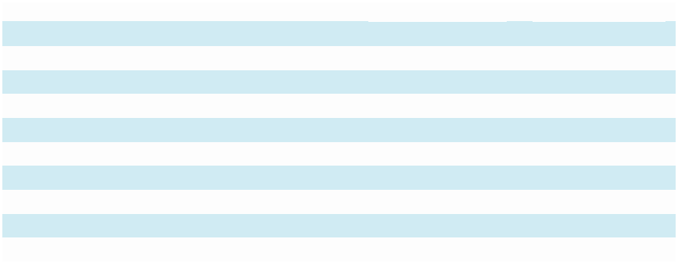

 |  | High |  |  | Low
Year Ended December 31, 2022
First Quarter | $ | 2.63 | $ |  | 1.76
Second Quarter | $ | 2.35 | $ |  | 1.25
Third Quarter | $ | 2.23 | $ |  | 1.24
Fourth Quarter | $ | 1.89 | $ |  | 1.34
Year Ended December 31, 2023
First Quarter | $ | 2.16 | $ |  | 1.72
Second Quarter | $ | 2.17 | $ |  | 1.69
Third Quarter | $ | 2.11 | $ |  | 1.31
Fourth Quarter | $ | 2.11 | $ |  | 1.25

Holders

As of March 25, 2024, there was 1 stockholder of record of our Class A common stock and there were approximately 38 stockholders of record of our Class B common stock, respectively. Since many of our shares of Class B common stock are held by brokers and other institutions on behalf of stockholders, we are unable to estimate the total number of stockholders represented by these record holders.

Issuer Purchases of Equity Securities

In November 2014, we established a 2014 share repurchase program, which supersedes and replaces any prior repurchase programs, and authorized the Company to repurchase up to 3,000,000 shares in the aggregate of the Company’s Class B common stock. During the fourth quarter of 2023, we did not have any share repurchases under this program and 1,319,128 Class B common shares remain available for purchase under the plan.

ITEM 6. SELECTED FINANCIAL DATA.

As a smaller reporting company under SEC Regulations, we are not required to provide this information.

25

ITEM 7. MANAGEMENT’S DISCUSSION AND ANALYSIS OF FINANCIAL CONDITION AND RESULTS OF OPERATIONS.

The following discussion should be read in conjunction with the audited Consolidated Financial Statements and the notes to those statements which appear elsewhere in this Annual Report on Form 10-K. This discussion contains forward-looking statements. Please see page 1 on this Annual Report on Form 10-K “Forward-Looking Statements” and Item 1A of this Annual Report on Form 10-K under the caption “Risk Factors” for a discussion of the risks, uncertainties and assumptions associated with these statements.

Overview

Marchex harnesses the power of AI and omnichannel conversational intelligence to provide actionable insights aligned with prescriptive vertical market data analytics, driving operational excellence and revenue acceleration. We enable executive, sales and marketing teams to optimize customer journey experiences across communications channels and align enterprise strategy, empowering businesses to increase revenue through informed decision-making and strategic execution. Marchex provides conversational intelligence AI-powered solutions for market-leading companies in many leading B2B2C vertical markets, including several of the world’s most innovative and successful brands.

Our mission is to create intelligence around all types of business conversations. We desire to be a leader in vertical market conversational intelligence leveraging generative artificial intelligence and data analytics. We seek to empower performance improvements for our customers by giving them actionable, real-time insights into the conversations they are having with their customers across phone, text and other communication channels. We have assembled a set of applications that incorporate artificial intelligence (“AI”) functionality for enterprises that depend on phone calls, texts and other communication channels to help convert prospects into customers, enabling compelling customer experiences during the sales process and helping maximize returns. Our proprietary data and conversational insights help enable brands to personalize customer interactions in order to accelerate sales and capture more opportunities to grow their business. We serve large enterprises with a distributed footprint that interact with their customers across multiple communication paths.

We were incorporated in Delaware on January 17, 2003.

We have offices in Seattle, Washington; and Wichita, Kansas.

Recent Developments

New Product Launch

In November 2023, Marchex announced its launch of Call Summary and Sentiment Suite capabilities. Powered by generative AI, these new features analyze and generate summaries of consumer-to-business calls, enabling businesses to identify customers who have had exceptionally good experiences, as well as dissatisfied customers. This valuable data empowers companies to capitalize on positive interactions by advancing sales processes or encouraging positive online behaviors, including reviews, as well as take action to rectify concerns from dissatisfied customers.

The Call Summary feature offers two distinct types of summaries:

Outcome Focused Summaries give concise, natural-language descriptions of what occurred during a consumer-to-business call.

Agent Focused Summaries provide comprehensive assessments of customer service or sales agent performance during calls.

The Sentiment Suite feature combines structured and unstructured data to provide a holistic view of customer emotions during conversations, including:

Customer Emotion gives a high-level assessment of whether conversations were positive, negative, or neutral.

26

Emotion Categories assign specific sentiments such as satisfied, frustrated, or confused to callers, enabling tailored response strategies.

View of Business combines emotion grading and call context to infer how the customer perceives your business: positive, negative, or neutral.

These structured data pieces are then paired with natural language explanations of why callers are reacting the way they are, enhancing the understanding of emotional dynamics during conversations. Call Summaries and Sentiment Suite are just the first in a series of AI enhancements in Marchex’s product pipeline, all designed to equip organizations with applications to proactively identify sales and growth opportunities, as well as address issues that may lead to negative experiences and reviews from dissatisfied customers.

Business Update

For our fiscal year ended December 31, 2023, our revenue was $49.9 million, which decreased by $2.3 million, or 5%, compared to $52.2 million for the fiscal year ended December 31, 2022. The decrease is attributable primarily to lower conversational volumes in 2023 compared to 2022, particularly with our small business listing and solutions resellers. While we do expect to see continued lower call volumes in the near term based on the continuation of certain volume trends from late 2023, we believe that previously won dealer channel and Auto OEM relationships ramping over the course of the year, extension of existing customers to multi-year arrangements, expansion of our go-to-market initiatives resulting in new customer relationships across our verticals, continued innovation in our AI capabilities and product offerings, and completion of the necessary infrastructure to accelerate product cross selling to existing and new customers may provide an opportunity for potential revenue growth.

We believe our operating expenses have prospective opportunity for further efficiencies as we continue to make advancements in our technology infrastructure and cloud initiatives, to "OneStack". OneStack enables our technologies and clients to be more easily managed in a less costly operating environment. It provides a streamlined product innovation and go to market approach, allowing our vertical market clients to potentially consume all our signals, data analytics and applied AI and also provides speed and scale for client onboarding while streamlining support and account management.

For additional information on the effects of our technology environment restructuring efforts on our business and operations, refer to “Results of Operations” within this discussion and analysis and Item 1 of Part I, “Business.”

Factors Affecting our Performance

We utilize phone numbers as part of a number of analytics services to our customers such as our call and text analytics and communications. If we are not able to secure or retain sufficient phone numbers needed for our services or we are limited in the number of available telecommunication carriers or vendors to provide such phone numbers to us in the event of any industry consolidation or if telecommunication carriers or vendors were to experience system disruptions, our revenue and results of operations, and our ability to grow, may be materially and adversely affected.

Our quarterly results have fluctuated in the past and may fluctuate in the future due to seasonality. Our experience has shown that during the spring and summer months, call volumes in certain verticals such as home services are generally higher than during other times of the year and during the latter part of the fourth quarter of the calendar year we generally experience lower call volumes. The extent to which call volumes may decrease during these off-peak periods is difficult to predict. Prolonged or severe decreases in call volumes during these periods may adversely affect our growth rate and results and in turn the market price of our securities. Historically, we have seen this trend generally reversing in the first quarter of the calendar year with increased call volumes and often new budgets at the beginning of the year for many of our customers with fiscal years ending December 31. However, there can be no assurances such seasonal trends will consistently repeat each year.

We believe that our future revenue growth will depend on, among other factors, our ability to attract new customers, compete effectively, maximize our sales efforts, successfully improve existing analytics products and sales engagement solutions, and develop successful new products and solutions. If we are unable to generate adequate revenue growth and to manage our expenses, we may continue to incur significant losses in the future and may not be able to achieve or maintain profitability.

27

Climate Change

We have considered specific risks associated as a result of climate change legislation or regulation and determined that in their current form, legislation or regulation is not reasonably likely to have a material effect on our financial condition or results of operations. However, further iteration of the proposed legislation may yield different results.

Components of the Results of our Operations

Revenue

We generate the majority of our revenues from our conversational intelligence product offerings. Our AI-powered conversational analytics technology platform provides data and insights into the conversations our clients are having with their customers across phone, text and other communication channels. Our tools enable brands to personalize customer interactions in order to accelerate sales and capture more opportunities to grow their business. We generate revenue when our customers pay us a fee for each call/text or call/text related data element they receive from calls or texts or for each phone number tracked based on a pre-negotiated rate. Customers typically receive the benefit of our services as they are performed and substantially all of our revenue is recognized over time as services are performed.

In certain cases, we record revenue based on available and reported preliminary information from third parties. Collection on the related receivables may vary from reported information based upon third party refinement of the estimated and reported amounts owed that occurs subsequent to period ends.

Service Costs

Our service costs represent the cost of providing our services to our customers. These costs primarily consist of telecommunication costs, including the use of phone numbers relating to our services; colocation service charges of our network equipment; bandwidth and software license fees; network operations; and payroll and related expenses of personnel, including stock based compensation.

Sales and Marketing

Sales and marketing expenses consist primarily of payroll and related expenses for personnel engaged in marketing and sales functions; advertising and promotional expenditures including online and outside marketing activities; cost of systems used to sell to and serve customers; and stock-based compensation of related personnel.

Product Development

Product development costs consist primarily of expenses incurred in the research and development, creation and enhancement of our products and services.

Our research and development expenses include payroll and related expenses for personnel; costs of computer hardware and software; costs incurred in developing features and functionality of the services we offer; and stock-based compensation of related personnel.

For the periods presented, substantially all of our product development expenses are research and development. Product development costs are expensed as incurred or capitalized into property and equipment in accordance U.S. GAAP.

General and Administrative

General and administrative expenses consist primarily of payroll and related expenses for executive and administrative personnel; professional services, including accounting, legal and insurance; bad debt provisions; facilities costs; other general corporate expenses; and stock-based compensation of related personnel.

28

Stock-Based Compensation

We measure stock-based compensation cost at the grant date based on the fair value of the award and recognize it as expense over the vesting or service period, as applicable, of the stock-based award using the straight-line method. We account for forfeitures as they occur. Stock-based compensation expense is included in the same lines as compensation paid to the same employees in the Consolidated Statements of Operations.

Amortization of Intangibles from Acquisitions

Amortization of intangible assets excluding goodwill relates to intangible assets identified in connection with our acquisitions. The intangible assets have been identified as customer relationships; acquired technology; non-competition agreements; trade names. These assets are amortized over useful lives ranging from 12 to 60 months.

Provision for Income Taxes

We utilize the asset and liability method of accounting for income taxes. Under this method, deferred tax assets and liabilities are recognized for the future tax consequences attributable to differences between the financial statement carrying amounts of existing assets and liabilities and their respective tax bases and operating loss and tax credit carryforwards. Deferred tax assets and liabilities are measured using enacted tax rates expected to apply to taxable income in the years in which those temporary differences are expected to be recovered or settled. The effect on deferred tax assets and liabilities of a change in tax law is recognized in results of operations in the period that includes the enactment date.

Results of Operations

The following table presents revenue and certain of our operating results as a percentage of revenue:
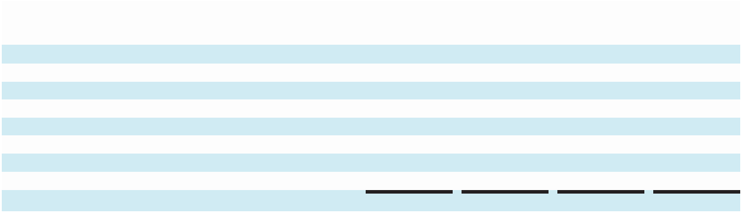

 | Year Ended |  |  |  | Year Ended
 | December 31, |  | % of |  | December 31, |  | % of
(In Thousands, Except Percentages) | 2022 |  | revenue |  | 2023 |  | revenue
Revenue | $52,170 |  | 100% |  | $49,910 | 100%
Expenses:
Service costs | $20,462 |  | 39% |  | $20,582 | 41%
Sales and marketing | 13,517 |  | 26% |  | 11,412 | 23%
Product development | 14,355 |  | 28% |  | 15,355 | 31%
General and administrative | 9,787 |  | 19% |  | 10,205 | 20%
Amortization of intangible assets from acquisitions | 2,124 |  | 4% |  | 1,987 | 4%
Acquisition and disposition related costs | 74 |  | 0% |  | 12 | 0%
Total operating expenses | 60,319 |  | 116% |  | 59,553 | 119%

Stock-based compensation expense was included in the following operating expense categories as follows:


 |  |  | Year Ended December 31,
(In Thousands) |  |  | 2022 |  |  | 2023
Service costs | $ |  | 171 | $ |  | 2
Sales and marketing |  |  | 796 |  |  | 663
Product development |  |  | 293 |  |  | 114
General and administrative |  |  | 1,386 |  |  | 1,613
Total stock-based compensation | $ |  | 2,646 | $ |  | 2,392

See Note 6: Stockholders' Equity (b). Stock Option Plan of the Notes to Consolidated Financial Statements, as well as our Critical Accounting Policies for additional information about stock-based compensation.

29

Revenue

Revenue decreased $2.3 million, or 5%, from $52.2 million for the year ended December 31, 2022 to $49.9 million for the year ended December 31, 2023. This decrease was impacted primarily by lower conversational volumes in 2023 as compared to 2022.

In the immediate near term, we expect our revenues to be somewhat lower compared to the most recent quarter as we continue to see macroeconomic pressures on certain customer segments to start the year in 2024, to include continued anticipated lower volumes from our small business reseller customers and lower volumes in our Home Services customers potentially due to moderate winter weather conditions.

In the longer term, we believe that previously won dealer channel and Auto OEM relationships ramping over the course of the year, extension of existing customers to multi-year arrangements, expansion of our go-to-market initiatives resulting in new customer relationships across our verticals, continued innovation in our AI capabilities and product offerings, and completion of the necessary infrastructure to accelerate product cross selling to existing and new customers may provide an opportunity for potential revenue growth.

For additional discussion of trends and other factors in our business, refer to Key Trends Driving our Industry and Business in Item 1 of this Annual Report on Form 10-K.

Expenses

Service Costs. Service costs increased $0.1 million from $20.5 million for the year ended December 31, 2022 to $20.6 million for the year ended December 31, 2023. As a percentage of revenue, service costs were 39% and 41% for the year ended December 31, 2022 and 2023, respectively. The change from the prior year was primarily due to $0.2 million higher cloud compute and storage costs to support our growing technology infrastructure and related conversational data assets, partially offset by $0.2 million lower stock-based compensation.

We expect in the near and intermediate term that service costs in absolute dollars will be similar to or modestly higher in relation to the most recent period. There may be a positive impact on service costs as a percentage of revenue and further benefit in the event we generate contribution from new launches of analytics products and sales engagement solutions.

In the longer term, we believe that the successful completion of the OneStack initiative (refer to Business Update in Item 7 of this Annual Report on Form 10-K) and acceleration of our vertical market growth strategy may provide an opportunity for potential gross margin improvement.

Sales and Marketing. Sales and marketing expenses decreased $2.1 million, or 18%, from $13.5 million for the year ended December 31, 2022 to $11.4 million for the year ended December 31, 2023. As a percentage of revenue, sales and marketing expenses were 26% and 23% for the year ended December 31, 2022 and 2023, respectively. The change from the prior year was primarily attributable to lower personnel costs of $1.9 million as we realigned and focused our go-to-market initiatives.

We expect some volatility in sales and marketing expenses based on the timing of marketing and customer engagement initiatives, but in the near term, we expect these costs to be similar to or modestly higher than the most recent quarter or increase modestly as revenues increase. We also expect, to the extent that we increase our marketing activities, this could correspondingly also cause an increase in sales and marketing expenses as a percentage of revenue.

Product Development. Product development expenses increased $1.0 million, or 7%, from $14.4 million for the year ended December 31, 2022 to $15.4 million for the year ended December 31, 2023. As a percentage of revenue, product development expenses were 28% and 31% for the year ended December 31, 2022 and 2023, respectively. The net increase in dollars and as a percentage of revenue was primarily attributable to a decrease in support services fee recovery of $1.4 million, partially offset by lower personnel costs totaling $0.6 million.

In the near and intermediate term, we expect that product development expenses, in absolute dollars and as a percentage of revenue, will be similar to or modestly higher than the most recent quarter, as we continue to invest in our products and in building AI to expand our conversational intelligence capabilities.

30

General and Administrative. General and administrative expenses increased $0.4 million or 4%, from $9.8 million for the year ended December 31, 2022 to $10.2 million for the year ended December 31, 2023. As a percentage of revenue, general and administrative expenses were 19% and 20% for the year ended December 31, 2022 and 2023, respectively. The net increase in dollars was primarily attributable to a decrease in support services fee recovery of $0.8 million and an increase in our provision for bad debt of $0.3 million due to an increase in delinquent customer accounts in 2023, partially offset by lower personnel costs totaling $0.6 million.

We expect some volatility in general and administrative expenses, primarily related to professional fees and insurance, based on the timing of regulatory updates in connection with our being a public company. We also expect fluctuations in our general and administrative expenses related to stock-based compensation, as the recognition of stock-based compensation expense is impacted by market conditions relating to our stock price.

In the near and intermediate term, we expect our general and administrative expenses to be similar to or modestly lower than the most recent quarter, as we focus on cost management and enhancing overall operational efficiency. In the longer term, to the extent that we expand our operations and issue additional stock-based compensation, general and administrative expenses, in absolute dollars and as a percentage of revenue, could increase.

Amortization of Intangible Assets from Acquisitions. Intangible amortization expenses were $2.1 million and $2.0 million for the year ended December 31, 2022 and 2023, respectively. This expense was associated with amortization of intangible assets acquired from business acquisitions made in 2018 and 2019, and is further categorized as service costs or sales and marketing expense in the Company's Consolidated Statements of Operations based on the nature of the underlying intangible asset. We expect intangible asset amortization to decrease in the near term, as a result of certain assets reaching the end of their useful lives.

Interest Income and Other, net. The interest income and other, net for the year ended December 31, 2022 and 2023 was interest income of $88.0 thousand and interest expense of $173.0 thousand, respectively. The change from the prior year was primarily due to an increase in interest expense on new equipment financing and a net loss recognized from equipment disposal transactions in 2023.

Income Tax. Income tax expense for the years ended December 31, 2022 and 2023 was $184.0 thousand and $94.0 thousand, respectively, consisting primarily of state income taxes in 2023 and a combination of state and international tax expense and in 2022. The effective tax rate differed from the expected tax rate of 21% in both years primarily due to a full valuation allowance and, to a lesser extent, changes in tax rates applied to ending deferred asset and liability balances, non-deductible stock-based compensation related to incentive stock options recorded under the fair-value method, and other non-deductible amounts.

At December 31, 2023, based on all the available evidence, both positive and negative, we determined that it is more likely than not that our deferred tax assets will not be realized and accordingly, we have recorded a full valuation allowance of $54.1 million against our net deferred tax assets ($54.3 million of deferred tax assets that are partially offset by $0.4 million in reversing deferred tax liabilities). This compares to a full valuation allowance of $51.8 million at December 31, 2022 ($52.9 million of deferred tax assets that are partially offset by $1.3 million in reversing deferred tax liabilities). In assessing the realizability of deferred tax assets, based on all the available evidence, both positive and negative, we considered whether it is more likely than not that some or all of the deferred tax assets will be realized. The ultimate realization of deferred tax assets depends on the generation of future taxable income during the periods in which those temporary differences are deductible. We considered the future reversal of deferred tax liabilities, carryback potential, projected taxable income, and tax planning strategies as well as the Company’s history of taxable income or losses in the relevant jurisdictions in making this assessment. We have incurred federal taxable losses in 2022 and 2023.

Net Loss. Net loss increased $1.7 million, or 17%, from $8.2 million in 2022 compared to $9.9 million in

2023. The increase in net loss for the year ended December 31, 2023 was primarily attributable to the $2.3 million decrease in revenue discussed above, partially offset by a net decrease in total operating expenses of $0.8 million, which was driven by the decrease in sales and marketing expenses discussed above.

31

Liquidity and Capital Resources

As of December 31, 2022 and 2023, we had cash and cash equivalents of $20.5 million and $14.6 million, respectively. As of December 31, 2023, we had current and non-current contractual obligations of $0.9 million, of which $0.2 million is for rent under our facility operating leases.

Cash used in operating activities was $4.4 million during the year ended December 31, 2023. The cash used in operating activities was primarily a result of a net loss of $9.9 million, adjusted for non-cash items of $7.1 million, which primarily included depreciation and amortization and stock-based compensation partially offset by changes in working capital of $1.6 million. The change in working capital was driven primarily by a decrease in accrued expenses and other current liabilities as well as a decrease in accounts payable and deferred revenue partially offset by an increase in accounts receivable. Cash used in operating activities was $2.3 million during the year ended December 31, 2022. The cash used in operating activities was primarily a result of a net loss of $8.2 million, adjusted for non-cash items of $7.6 million, which primarily included depreciation and amortization and stock-based compensation, offset by changes in working capital of $1.7 million. The change in working capital was driven primarily by an increase in accounts receivable as well as a decrease in deferred revenue and accrued expenses partially offset by an increase in accounts payable.

Cash used in operating activities for the year ended December 31, 2023 included higher costs to assist in reorganizing and efforts to reduce our on-going operating costs. We believe that those initiatives should benefit us through lower operating expenses in the near and intermediate term. To the extent we are unable to effectively execute these operational initiatives or our revenue growth initiatives, our revenues could be lower, and our costs could be consistent with or higher, than current levels, which would have an adverse impact on our future operating cash flows, liquidity, and profitability.

Cash used in investing activities for the years ended December 31, 2023 and December 31, 2022, was $1.3 million and $2.9 million, respectively, and was primarily attributable to cash paid for purchases of property and equipment for our technology infrastructure platform as well as capitalized software development costs in both years. We procured $0.8 million of additional server and other equipment under new financing lease agreements during the year ended December 31, 2023 with current borrowing of $0.8 million.

In the near and intermediate term, we expect property and equipment purchases and capitalized software development costs to be similar to or modestly higher compared to our most recent periods, as we continue our OneStack infrastructure initiatives and accelerate product innovation with more AI-powered features and capabilities launched throughout the year. In the longer term, we expect any increase in our operations to have a corresponding increase in capital expenditures required to support our systems and personnel.

Cash used in financing activities was $0.2 million during the year ended December 31, 2023, which was primarily attributable to payments made related to equipment financing lease obligations. Cash used in financing activities was $1.5 million during the year ended December 31, 2022, which was primarily attributable to the exchange of cash consideration for partial settlement of a contractual obligation partially offset by proceeds from stock options exercises and the employee stock purchase program.

In November 2014, our board of directors authorized a new share repurchase program (the “2014 Repurchase Program”) which supersedes and replaces any prior repurchase programs. Under the 2014 Repurchase Program, we are authorized to repurchase up to 3,000,000 shares of our Class B common stock in the aggregate through open market and privately negotiated transactions, at such times and in such amounts as we deem appropriate. Repurchases may also be made under a Rule 10b5-1 plan, which would permit shares to be repurchased when we might otherwise be precluded from doing so under insider trading laws. We have made no repurchases under the 2014 Repurchase Program for the years ended December 31, 2022 and 2023.

Based on our operating plans we believe that our resources will be sufficient to fund our operations, including any investments in strategic initiatives, for at least twelve months, however macroeconomic factors could influence our operating plans and resources significantly. Additional equity and debt financing may be needed to support our acquisition strategy, our long-term obligations, and our company’s needs. There can be no assurance that, if we needed additional funds, financing arrangements would be available in amounts or on terms acceptable to us, if at all. Failure to generate sufficient revenue or raise additional capital could have a material adverse effect on our ability to continue as a going concern and to achieve our intended business objectives.

32

Critical Accounting Policies

Our Consolidated Financial Statements have been prepared using accounting principles generally accepted in the United States (U.S. GAAP). Our critical accounting policies are those that we believe have the most significant impact to reported amounts of assets, liabilities, revenue and expenses and the related disclosures of contingent assets and liabilities and that require the most difficult, subjective, or complex judgments.

The policies below are critical to our business operations and the understanding of our results of operations. In the ordinary course of business, we make a number of estimates and assumptions relating to the reporting of our results. We base our estimates on historical experience and on various assumptions that we believe to be reasonable under the circumstances, the results of which form the basis for making judgments about the carrying values of assets and liabilities that are not readily apparent from other sources. Actual results may differ from these estimates under different assumptions or conditions.

While our significant accounting policies are more fully described in Note 1: Description of Business and Summary of Significant Accounting Policies and Practices, we believe the following topics reflect our critical accounting policies and our more significant judgment and estimates used in the preparation of our Consolidated Financial Statements.

Principles of Consolidation

The Consolidated Financial Statements include the Company and its wholly owned subsidiaries. All significant inter-company transactions and balances have been eliminated in consolidation.

Revenue

We generate the majority of our revenues from our conversational intelligence product offerings. Our customers pay us a fee for each call, text, or other communication related data element they receive from calls or texts or for each phone number tracked based on a pre-negotiated rate. As such, the majority of total revenue is derived from contracts that include consideration that is variable in nature. The variable elements of these contracts primarily include the number of transactions (for example, the number of qualified phone calls).

Customers typically receive the benefit of our services as they are performed and substantially all of our revenue is recognized over time as services are performed. The majority of the Company’s customers are invoiced on a monthly basis following the month of the delivery of services and are required to make payments under standard credit terms.

For arrangements that include multiple performance obligations, the transaction price from the arrangement is allocated to each respective performance obligation based on its relative standalone selling price and recognized when revenue recognition criteria for each performance obligation are met. The standalone selling price for each performance obligation is established based on the sales price at which we would sell a promised good or service separately to a customer or the estimated standalone selling price.

In certain cases, we record revenue based on available and reported preliminary information from third parties. Collection on the related receivables may vary from reported information based upon third-party refinement of the estimated and reported amounts owed that occurs subsequent to period ends.

Stock-Based Compensation

FASB ASC Topic 718, Compensation – Stock Compensation (ASC 718) requires the measurement and recognition of compensation for all stock-based awards made to employees, non-employees and directors including stock options, restricted stock issuances, and restricted stock units be based on estimated fair values. We account for forfeitures as they occur. We measure stock-based compensation cost at the grant date based on the fair value of the award and recognize it as expense over the vesting or service period, as applicable, of the stock-based award using the straight-line method.

33

We use the Black-Scholes option pricing model as our method of valuation for stock-based awards with time-based vesting. Our determination of the fair value of stock-based awards on the date of grant using an option pricing model is affected by our stock price as well as assumptions regarding a number of variables. These variables include, but are not limited to, the expected life of the award, our expected stock price, and volatility over the term of the award.

Although the fair value of stock-based awards is determined in accordance with ASC 718, Compensation – Stock Compensation the assumptions used in calculating fair value of stock-based awards and the use of the Black-Scholes option pricing model is highly subjective, and other reasonable assumptions could provide differing results. As a result, if factors change and we use different assumptions, our stock-based compensation expense could be materially different in the future. See Note 6: Stockholders' Equity(b). Stock Option Plan in the Notes to Consolidated Financial Statements for additional information.

Allowance for Doubtful Accounts and Customer Credits

Accounts receivable balances are presented net of allowance for doubtful accounts and customer credits. The allowance for doubtful accounts is our best estimate of the amount of probable credit losses in our accounts receivable. We determine our allowance based on analysis of historical bad debts, customer concentrations, customer creditworthiness and current economic trends. We review the allowance for collectability on a quarterly basis. Account balances are written off against the allowance after all reasonable means of collection have been exhausted and the potential recovery is considered remote. If the financial condition of our customers were to deteriorate, resulting in an impairment of their ability to make payments, or if we underestimated the allowances required, additional allowances may be required which would result in increased general and administrative expenses in the period such determination was made.

We determine our allowance for customer credits based upon our analysis of historical credits and expected revenue adjustments. Material differences may result in the amount and timing of our revenue for any period, stemming from differing management judgments and estimates.

Goodwill and Intangible Assets

Goodwill represents the excess of the purchase price over the fair value of identifiable assets acquired and liabilities assumed in business combinations accounted for under the purchase method. Intangible assets from acquisitions represent customer relationships, technologies, non-compete agreements, and trade names related to previous acquisitions. These assets are determined to have definite lives and are amortized on a straight-line basis over the estimated period over which we expect to realize economic value related to the intangible asset. The amortization periods range from one year to 5 years.

We apply the provisions of the FASB ASC Topic 350, “Intangibles - Goodwill and Other” (ASC 350) whereby assets acquired in a purchase business combination and determined to have an indefinite useful life are not amortized, but instead test for impairment at least annually. According to FASB ASC 360, “Property Plant and Equipment” (ASC 360), intangible assets with definite useful lives should be amortized over the respective estimated lives to their estimated residual values and reviewed for impairment. Intangible assets are "grouped" and evaluated for impairment at the lowest level of identifiable cash flows.

34

Goodwill is tested annually on November 30 for impairment. Goodwill and intangible assets are also tested more frequently if events and circumstances indicate that the assets might be impaired. The provisions of the accounting standard for goodwill and other intangible assets allow us to first assess qualitative factors to determine whether it is necessary to perform a quantitative impairment test. Events and circumstances considered in determining whether the carrying value of goodwill and intangible assets may not be recoverable include but are not limited to: significant changes in performance relative to expected operating results; significant changes in the use of the assets; and significant changes in competition and market dynamics. These estimates are inherently uncertain and can be affected by numerous factors, including changes in economic, industry or market conditions, changes in business operations, a loss of a significant customer, changes in competition or changes in the share price of common stock and market capitalization. If our stock price were to trade below book value per share for an extended period of time and/or we experience adverse effects of a continued downward trend in the overall economic environment, changes in the business itself, including changes in projected earnings and cash flows, we may have to recognize an impairment of all or some portion of our goodwill and intangible assets. An impairment loss is recognized to the extent that the carrying amount exceeds the asset or asset group’s fair value. If the fair value is lower than the carrying value, a material impairment charge may be reported in our financial results. We exercise judgment in the assessment of the related useful lives of intangible assets, the fair values, and the recoverability. In certain instances, the fair value is determined in part based on cash flow forecasts and discount rate estimates. We cannot accurately predict the amount and timing of any impairment of goodwill or intangible assets. Should the value of goodwill or intangible assets become impaired, we would record the appropriate charge. Any future impairment charges could have a material adverse effect on our financial condition and results of operations.

Provision for Income Taxes

We are subject to income taxes in the U.S. and certain international jurisdictions. Judgment is required in evaluating our uncertain tax positions and determining our provision for income taxes. We utilize the asset and liability method of accounting for income taxes. Under this method, deferred tax assets and liabilities are recognized for the future tax consequences attributable to differences between the financial statement carrying amounts of existing assets and liabilities and their respective tax bases and operating loss and tax credit carryforwards. Deferred tax assets and liabilities are measured using enacted tax rates expected to apply to taxable income in the years in which those temporary differences are expected to be recovered or settled. The effect on deferred tax assets and liabilities of a change in tax law is recognized in results of operations in the period that includes the enactment date.

We determined that it is not more likely than not that our deferred tax assets (excluding certain insignificant Canadian deferred tax assets) will be realized and accordingly recorded 100% valuation allowance against these deferred tax assets as of December 31, 2022 and 2023. In assessing whether it is more likely than not that our deferred tax assets will be realized, factors considered included: historical taxable income, projected revenues and expenses, macroeconomic conditions, issues facing the industry, existing contracts, our ability to project future results and any appreciation of its other assets. The ultimate realization of deferred tax assets depends on the generation of future taxable income during the periods in which those temporary differences are deductible. We considered the future reversal of deferred tax liabilities, carryback potential, projected taxable income, and tax planning strategies as well as our history of taxable income or losses in the relevant jurisdictions in making this assessment. Based on the level of historical taxable losses and the uncertainty of projections for future taxable income over the periods for which the deferred tax assets are deductible, we concluded that it is not more likely than not that the gross deferred tax assets will be realized.

From time to time, various state, federal, and other jurisdictional tax authorities undertake reviews of us and our filings. We believe any adjustments that may ultimately be required as a result of any of these reviews will not be material to the Consolidated Financial Statements.

ITEM 7A. QUANTITATIVE AND QUALITATIVE DISCLOSURES ABOUT MARKET RISK.

As a smaller reporting company under SEC Regulations, we are not required to provide this information.

35

ITEM 8. FINANCIAL STATEMENTS AND SUPPLEMENTARY DATA.

INDEX TO FINANCIAL STATEMENTS

 | Page
Marchex, Inc.
Report of Independent Registered Public Accounting Firm, RSM US LLP (PCAOB ID: 49) | 37
Consolidated Balance Sheets as of December 31, 2022 and 2023 | 39
Consolidated Statements of Operations for the years ended December 31, 2022 and 2023 | 40
Consolidated Statements of Stockholders’ Equity for the years ended December 31, 2022 and 2023 | 41
Consolidated Statements of Cash Flows for the years ended December 31, 2022 and 2023 | 42
Notes to Consolidated Financial Statements | 43

36

Report of Independent Registered Public Accounting Firm

To the Shareholders and the Board of Directors of Marchex, Inc.

Opinion on the Financial Statements

We have audited the accompanying Company's Consolidated Balance Sheets of Marchex, Inc. and its subsidiaries (the Company) as of December 31, 2023 and December 31, 2022, the related consolidated statements of operations, stockholders’ equity and cash flows for each of the two years in the period ended December 31, 2023 and the related notes to the consolidated financial statements (collectively, the financial statements). In our opinion, the financial statements present fairly, in all material respects, the financial position of the Company as of December 31, 2023 and December 31, 2022, and the results of its operations and its cash flows for the years then ended, in conformity with accounting principles generally accepted in the United States of America.

Basis for Opinion

These financial statements are the responsibility of the Company's management. Our responsibility is to express an opinion on the Company's financial statements based on our audits. We are a public accounting firm registered with the Public Company Accounting Oversight Board (United States) (PCAOB) and are required to be independent with respect to the Company in accordance with U.S. federal securities laws and the applicable rules and regulations of the Securities and Exchange Commission and the PCAOB.

We conducted our audits in accordance with the standards of the PCAOB. Those standards require that we plan and perform the audit to obtain reasonable assurance about whether the financial statements are free of material misstatement, whether due to error or fraud. The Company is not required to have, nor were we engaged to perform, an audit of its internal control over financial reporting. As part of our audits we are required to obtain an understanding of internal control over financial reporting but not for the purpose of expressing an opinion on the effectiveness of the Company's internal control over financial reporting. Accordingly, we express no such opinion.

Our audits included performing procedures to assess the risks of material misstatement of the financial statements, whether due to error or fraud, and performing procedures that respond to those risks. Such procedures included examining, on a test basis, evidence regarding the amounts and disclosures in the financial statements. Our audits also included evaluating the accounting principles used and significant estimates made by management, as well as evaluating the overall presentation of the financial statements. We believe that our audits provide a reasonable basis for our opinion.

Critical Audit Matter

The critical audit matter communicated below is a matter arising from the current period audit of the financial statements that was communicated or required to be communicated to the audit committee of the board of directors and that: (1) related to an account and disclosures that are material to the financial statements and (2) involved our especially challenging, subjective or complex judgments. The communication of the critical audit matter does not alter in any way our opinion on the financial statements, taken as a whole, and we are not, by communicating the critical audit matter below, providing a separate opinion on the critical audit matter or on the account or disclosures to which it relates.

Occurrence of Revenues

As described in Note 1 of the consolidated financial statements, the Company generates its revenues through a significant volume of low-dollar transactions tracked and recorded in a highly automated process within the Company’s internally developed information technology systems. The Company recognizes revenue from its call analytics technology platform when customers pay a fee for each qualified transaction generated per the terms of the customer contract. Revenue is recognized over time as the service is performed.

We identified the occurrence of revenue as a critical audit matter as the processes to track and record revenues are highly automated. These internally developed systems are complex and require an increased audit effort around assessing the reliability of data.

37

Our audit procedures related to the occurrence of revenue included performing the following audit procedures, among others:

On a sample basis, we obtained the customer invoice, the supporting call log data from the Company’s internal tracking system relating to the invoiced period, and the underlying customer contracts. For each sample:

- We recalculated the invoiced amount based on the call and/or text volume, agreeing the terms and conditions to the customer contract;

- We evaluated performance obligations and the applicable billing period, and agreed to the customer billing and recorded revenue during the selected period;

- We verified the existence of call data by listening to a sample of recorded calls and of text message data by viewing a sample of text logs and traced to cash received for samples selected;

We performed substantive analytical procedures over the Company’s revenue which included comparing our expected rate per call during the selected period to the rate per call derived from the Company’s call log data and recorded revenue for the selected period; and

We verified reliability of system data by obtaining management's analysis of call minutes per the system and compared to third party vendor invoices for completeness and accuracy for a sample of months.

/s/ RSM US LLP

We have served as the Company's auditor since 2022.

Seattle, Washington
March 29, 2024

38

MARCHEX, INC. AND SUBSIDIARIES

Consolidated Balance Sheets


 |  |  | As of December 31,
(In Thousands, Except Per Share Amounts) |  |  | 2022 |  |  |  | 2023
Assets
Current assets:
Cash and cash equivalents | $ |  | 20,474 |  | $ |  | 14,607
Accounts receivable, net |  |  | 8,396 |  |  |  | 7,394
Prepaid expenses and other current assets |  |  | 2,015 |  |  |  | 1,805
Total current assets |  |  | 30,885 |  |  |  | 23,806
Property and equipment, net |  |  | 4,050 |  |  |  | 2,398
Other assets, net |  |  | 973 |  |  |  | 1,482
Right-of-use lease asset |  |  | 738 |  |  |  | 1,631
Goodwill |  |  | 17,558 |  |  |  | 17,558
Intangible assets from acquisitions, net |  |  | 2,590 |  |  |  | 602
Total assets | $ |  | 56,794 |  | $ |  | 47,477
Liabilities and Stockholders’ Equity
Current liabilities:
Accounts payable | $ |  | 2,037 |  | $ |  | 1,533
Accrued benefits and payroll |  |  | 3,566 |  |  |  | 3,294
Other accrued expenses and current liabilities |  |  | 3,825 |  |  |  | 3,217
Deferred revenue and deposits |  |  | 1,384 |  |  |  | 1,214
Lease liability current |  |  | 1,252 |  |  |  | 462
Total current liabilities |  |  | 12,064 |  |  |  | 9,720
Deferred tax liabilities |  |  | 233 |  |  |  | 249
Finance lease, non-current |  |  | — |  |  |  | 421
Lease liability, non-current |  |  | 385 |  |  |  | 1,217
Total liabilities | $ |  | 12,682 |  | $ |  | 11,607
Commitments and contingencies - See Note 4
Stockholders’ equity:
Common stock, $0.01 par value. Authorized 137,500 shares
Class A: 12,500 shares authorized; 4,661 shares issued and
outstanding at December 31, 2022 and 2023 |  |  | 49 |  |  |  | 49
Class B: 125,000 shares authorized; 38,497 shares issued and
outstanding at December 31, 2022, including 1,105 shares
of restricted stock; and 38,662 shares issued and outstanding at
December 31, 2023, including 720 shares of restricted stock |  |  | 385 |  |  |  | 386
Additional paid-in capital |  |  | 354,999 |  |  |  | 356,666
Accumulated deficit |  |  | (311,321) |  |  |  | (321,231)
Total stockholders’ equity |  |  | 44,112 |  |  |  | 35,870
Total liabilities and stockholders’ equity | $ |  | 56,794 |  | $ |  | 47,477

See accompanying Notes to Consolidated Financial Statements.

39

MARCHEX, INC. AND SUBSIDIARIES

Consolidated Statements of Operations
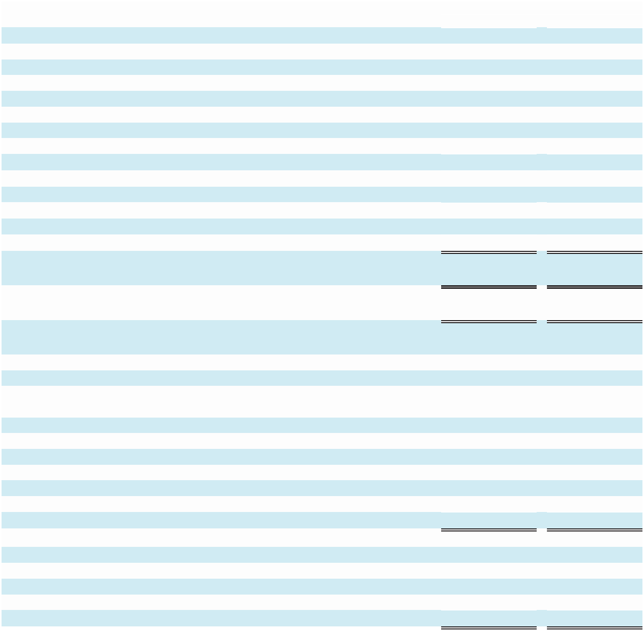

 | Years Ended December 31,
(In Thousands, Except Per Share Amounts) | 2022 |  |  | 2023
Revenue | $52,170 |  |  | $49,910
Expenses:
Service costs ⁽¹⁾⁽³⁾ | 20,462 |  |  | 20,582
Sales and marketing ⁽¹⁾⁽³⁾ | 13,517 |  |  | 11,412
Product development ⁽³⁾ | 14,355 |  |  | 15,355
General and administrative ⁽¹⁾⁽³⁾ | 9,787 |  |  | 10,205
Amortization of intangible assets from acquisitions ⁽²⁾ | 2,124 |  |  | 1,987
Acquisition and disposition related benefits | 74 |  |  | 12
Total operating expenses | 60,319 |  |  | 59,553
Loss from operations | (8,149) |  |  | (9,643)
Interest income (expense) and other, net | 88 |  |  | (173)
Loss before provision for income taxes | (8,061) |  |  | (9,816)
Income tax expense | 184 |  |  | 94
Net loss applicable to common stockholders | $(8,245) |  |  | $(9,910)
Basic and diluted net loss per Class A share
applicable to common stockholders | $(0.19) |  |  | $(0.23)
Basic and diluted net loss per Class B share
applicable to common stockholders | $(0.19) |  |  | $(0.23)
Shares used to calculate basic net loss per share
applicable to common stockholders:
Class A | 4,661 |  |  | 4,661
Class B | 38,560 |  |  | 37,960
Shares used to calculate diluted net loss per share
applicable to common stockholders:
Class A | 4,661 |  |  | 4,661
Class B | 43,221 |  |  | 42,621
⁽¹⁾ Excludes amortization of intangibles from acquisitions
⁽²⁾ Components of amortization of intangibles from acquisitions:
Service costs | $467 |  |  | $467
Sales and marketing | 1,657 |  |  | 1,520
Total | $2,124 |  |  | $1,987
⁽³⁾ Components of related party support services fee recovery
Service costs | $2,648 |  |  | $1,115
Sales and marketing | 742 |  |  | 90
Product development | 1,612 |  |  | 172
General and administrative | 1,396 |  |  | 147
Total | $6,398 |  |  | $1,524

See accompanying Notes to Consolidated Financial Statements.

40

MARCHEX, INC. AND SUBSIDIARIES

Consolidated Statements of Stockholders’ Equity
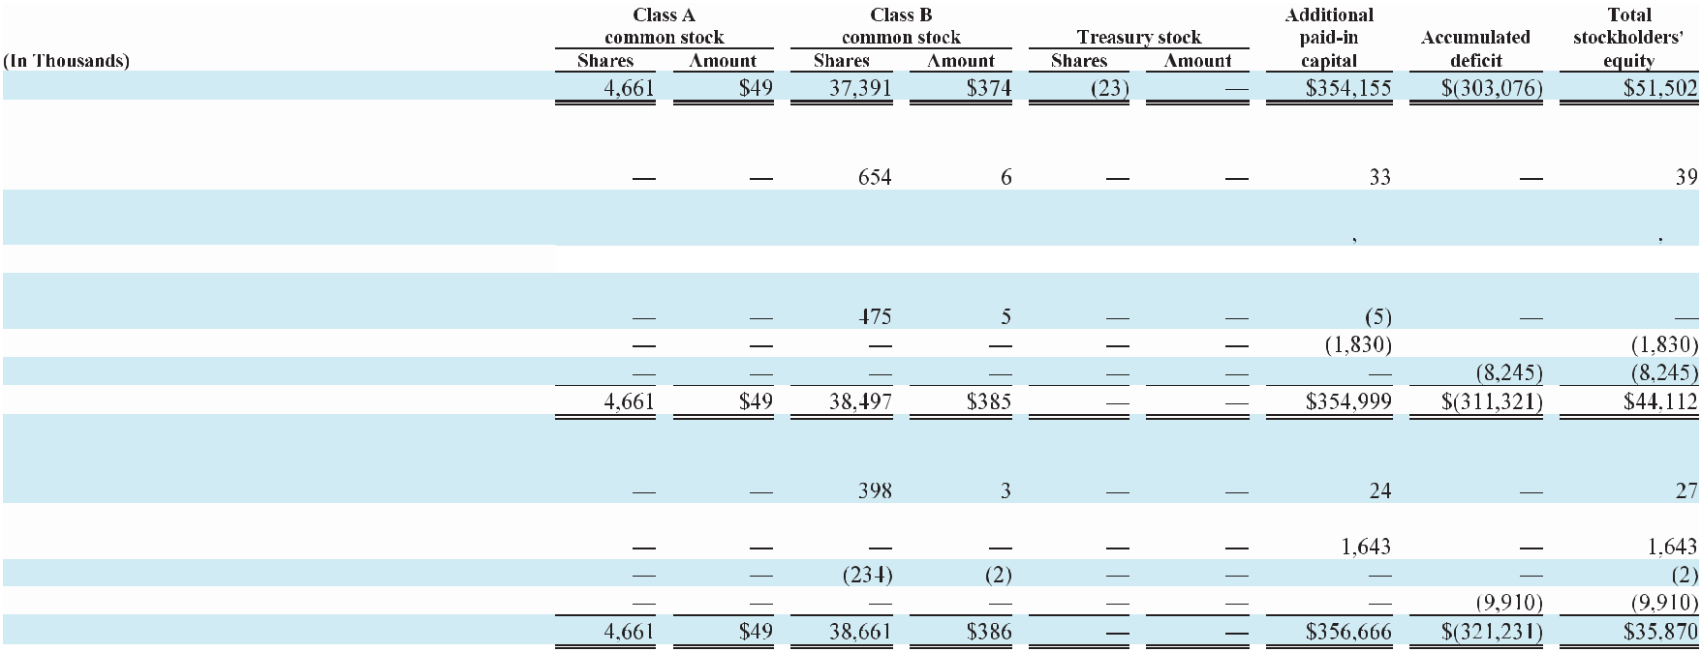

Balance at December 31, 2021

Issuance of common stock upon exercise of options,
issuance and vesting of restricted stock and under
employee stock purchase plan, net
Stock-based compensation from options and

restricted stock, net of forfeitures Repurchase and retirement of treasury stock Issuance of Class B common stock in connection with

prior deferred issuance from acquisition

Settlement of a contractual obligation

Net loss

Balance at December 31, 2022

Issuance of common stock upon exercise of options,
issuance and vesting of restricted stock and under
employee stock purchase plan, net
Stock-based compensation from options and
restricted stock, net of forfeitures
Repurchase and retirement of treasury stock
Net loss

Balance at December 31, 2023

See accompanying Notes to Consolidated Financial Statements.

41

MARCHEX, INC. AND SUBSIDIARIES

Consolidated Statements of Cash Flows
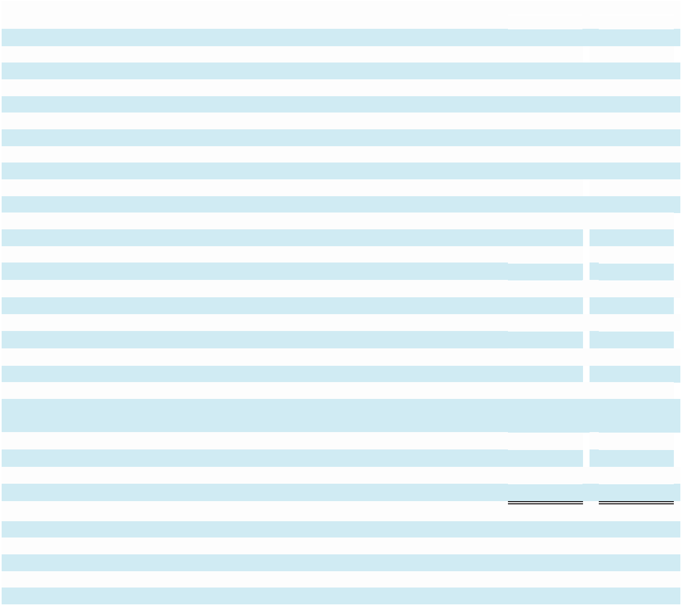

(In Thousands)

Cash flows from operating activities:
Net loss applicable to common stockholders

Adjustments to reconcile net loss to net cash provided by operating activities:

Amortization and depreciation
Allowance for doubtful accounts and customer credits

Deferred income taxes
Stock-based compensation
Gain (or loss) on disposal of fixed assets
Change in certain assets and liabilities:
Accounts receivable, net

Prepaid expenses, other current assets, and other assets Accounts payable

Accrued expenses and other current liabilities Deferred revenue and deposits
Net cash used in operating activities

Cash flows from investing activities:

Purchases of property and equipment Proceeds from sales of property and equipment
Net cash used in provided by investing activities

Cash flows from financing activities:
Settlement of a contractual obligation
Finance lease principal payments

Proceeds from exercises of stock options, issuance and vesting of restricted stock and employee stock purchase plan, net

Net cash used in financing activities

Net decrease in cash and cash equivalents
Cash and cash equivalents at beginning of period

Cash and cash equivalents at end of period

Supplemental disclosure of cash flow information:

Foreign government paycheck assistance and rent subsidies (operating activities)

Cash paid for operating leases (operating activities)
Cash paid during the period for income taxes, net of refunds

Supplemental disclosure of non-cash investing and financing activities:

Settlement of a contractual obligation

Years Ended December 31,
 | 2022 |  |  |  | 2023
$ | (8,245) |  | $ |  | (9,910)
 | 4,033 |  |  |  | 3,873
 | 906 |  |  |  | 641
 | 43 |  |  |  | —
 | 2,646 |  |  |  | 2,393
 | — |  |  |  | 178
 | (1,280) |  |  |  | 360
 | 73 |  |  |  | 1,152
 | 675 |  |  |  | (1,255)
 | (510) |  |  |  | (1,658)
 | (633) |  |  |  | (169)
 | (2,292) |  |  |  | (4,395)
 | (2,865) |  |  |  | (1,377)
 | — |  |  |  | 65
 | (2,865) |  |  |  | (1,312)
 | (1,495) |  |  |  | —
 | — |  |  |  | (185)
 | 40 |  |  |  | 25
 | (1,455) |  |  |  | (160)
 | (6,612) |  |  |  | (5,867)
 | 27,086 |  |  |  | 20,474
$ | 20,474 |  | $ |  | 14,607
$ | 10 |  | $ |  | —
$ | 1,648 |  | $ |  | 1,549
$ | 55 |  | $ |  | 70
$ | 335 |  | $ |  | —

See accompanying Notes to Consolidated Financial Statements.

42

MARCHEX, INC. AND SUBSIDIARIES

Notes to Consolidated Financial Statements

Note 1: Description of Business and Summary of Significant Accounting Policies and Practices

(a) Description of Business and Basis of Presentation

Marchex, Inc. (the “Company”) was incorporated in the state of Delaware on January 17, 2003. The Company is a conversation intelligence company that harnesses the power of AI and conversational intelligence to provide actionable insights aligned with prescriptive vertical market data analytics, driving operational excellence and revenue acceleration. Marchex enables executive, sales and marketing teams to optimize customer journey experiences across all communication channels. Through our prescriptive analytics solutions, we enable the alignment of enterprise strategy, empowering businesses to increase revenue through informed decision-making and strategic execution.

Divestiture

In October 2020, the Company sold its interests in certain assets related to its Local Leads Platform, Call Marketplace and other assets not related to core conversational analytics and sales engagement solutions. In connection with the divestiture, the Company entered into an administrative support services agreement with the related party purchaser pursuant to which the Company will provide services to the related party purchaser for a support service fee. See Note 10: Divestiture Support Services Agreement of the Notes to the Consolidated Financial Statements for additional information.

Basis of Presentation

The accompanying Consolidated Financial Statements have been prepared in accordance with accounting principles generally accepted in the United States ("U.S. GAAP"). The preparation of our Consolidated Financial Statements requires management to make estimates and assumptions that affect the amounts of assets and liabilities and disclosures of contingent assets and liabilities at the date of the financial statements and the reported amounts of revenue and expenses during the reporting period. The Company has used estimates related to several financial statement amounts, including revenues, allowance for doubtful accounts, useful lives for property and equipment and intangible assets, valuation of intangible assets, the fair value of stock options awards, the impairment of goodwill, and the valuation allowance for deferred tax assets. Actual results could differ from those estimates.

(b) Cash and Cash Equivalents

The Company considers all highly liquid investments with an original maturity of three months or less at the date of purchase to be cash equivalents. Cash equivalents consist primarily of money market funds.

(c) Fair Value of Financial Instruments

The Company had the following financial instruments as of December 31, 2022 and 2023: cash and cash equivalents, accounts receivable, accounts payable, and accrued liabilities. The carrying value of these financial instruments approximates their fair value based on the liquidity of these financial instruments and their short-term nature. Further, these financial instruments are considered at Level 1 fair value with observable inputs that reflect quoted prices for identical assets or liabilities in active markets. The following table provides information about the fair value of our cash and cash equivalents balance:
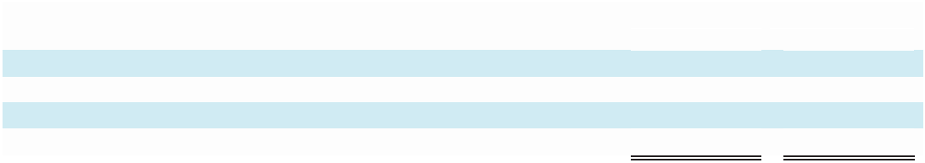

 |  |  | Years Ended December 31,
(In Thousands) |  |  | 2022 |  |  | 2023
Level 1 Assets:
Cash | $ |  | 9,020 | $ |  | 9,510
Money market funds |  |  | 11,454 |  |  | 5,097
Total cash and cash equivalents | $ |  | 20,474 | $ |  | 14,607

43

Assets, liabilities, and operations of foreign subsidiaries are recorded based on the functional currency of the entity. For a majority of our foreign operations, the functional currency is the U.S. dollar. Assets and liabilities denominated in other than the functional currency is remeasured each month with the remeasurement gain or loss recorded in Interest income (expense) and other, net in the Consolidated Statements of Operations.

(d) Accounts Receivable

Accounts receivable are recorded at the invoiced amount and do not bear interest. Accounts receivable balances are presented net of allowance for doubtful accounts.

Allowance for Doubtful Accounts

The allowance for doubtful accounts is the Company’s best estimate of the amount of expected credit losses in existing accounts receivable. The Company determines the allowance based on analysis of historical bad debts, customer concentrations, customer creditworthiness and current economic trends. Past due balances over 90 days and specific other balances are reviewed individually for collectability. The Company reviews accounts for collectability and the allowance for adequacy quarterly. Account balances are written off against the allowance after all means of collection have been exhausted and the potential for recovery is considered remote.

The allowance for doubtful accounts activity for the periods indicated is as follows:
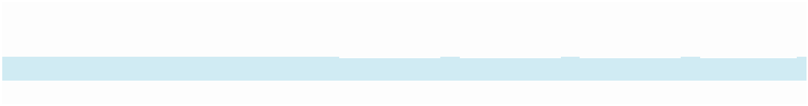

 |  | Balance at |  |  | Charged to |  |  | Write-offs, |  |  | Balance at
 |  | beginning |  |  | costs and |  |  | net of |  |  | end of
(In Thousands) |  | of period |  |  | expenses |  |  | recoveries |  |  | period
December 31, 2022 | $ | 266 | $ |  | 26 | $ |  | 125 | $ |  | 167
December 31, 2023 | $ | 167 | $ |  | 284 | $ |  | 331 | $ |  | 120

Allowance for Customer Credits

The allowance for customer credits is the Company’s best estimate of the amount of expected future reductions in customers’ payment obligations related to delivered services. The Company determines the allowance for customer credits based on analysis of historical credits and expected revenue adjustments.

The allowance for customer credits activity for the periods indicated is as follows:


 |  |  |  | Additions
 | Balance at |  |  |  | charged |  |  | Credits |  | Balance at
 | beginning |  |  |  | against |  | processed |  |  |  | end of
(In Thousands) |  | of period |  |  | revenue |  | and other |  |  |  | period
December 31, 2022 | $ | 157 |  | $ | 461 | $ |  | 534 | $ |  | 84
December 31, 2023 | $ | 84 |  | $ | 472 | $ |  | 445 | $ |  | 111

(e) Property and Equipment

Property and equipment are stated at cost. Depreciation on computers and other related equipment, purchased and internally developed software, and furniture and fixtures are calculated on the straight-line method over the estimated useful lives of the assets, generally averaging three years. Leasehold improvements are amortized straight-line over the shorter of the lease term or estimated useful lives of the assets generally ranging from five to eight years.

We capitalize certain software development costs incurred in connection with developing or obtaining computer software for internal use when both the preliminary project stage is completed, and it is probable that the software will be used as intended. Capitalized software costs include (i) external direct costs of materials and services utilized in developing computer software, (ii) compensation and related benefits for employees who are directly associated with the software projects. Capitalized software costs are amortized on a straight-line basis when placed into service over the estimated useful life of the software, generally averaging three years. We capitalized software development costs of $1.4 million and $0.4 million for the year ended December 31, 2022 and 2023, respectively.

44

(f) Leases

The Company determines whether an arrangement is a lease or contains a lease at inception of the arrangement. For arrangements considered leases, the Company assesses the lease for finance or operating classification and records a right-of-use asset and lease liability as of the commencement date. Finance leases are recorded on the Company's Consolidated Balance Sheets and interest is recognized and presented separately in Interest income (expense) and other on the Company's Consolidated Statements of Operations. Operating lease liabilities are recognized at the lease commencement date based on the present value of lease payments over the lease term. Right-of-use assets which represent the Company’s right to use the underlying asset for the lease term are amortized over the shorter of the useful life of the asset and the lease term. Operating leases with an initial term of 12 months or less are not recorded on the Company's Consolidated Balance Sheets.

(g) Goodwill

Goodwill represents the excess of the purchase price over the fair value of identifiable assets acquired and liabilities assumed in business combinations accounted for under the purchase method, net of recognized impairment.

Goodwill acquired in a purchase business combination is not amortized, but instead tested for impairment at least annually on November 30, and is tested for impairment more frequently if events and circumstances indicate that the asset might be impaired.

(h) Impairment or Disposal of Long-Lived Assets

The Company reviews its long-lived assets for impairment whenever events or changes in circumstances indicate that the carrying amount of an asset may not be recoverable. Recoverability of assets held and used is measured by a comparison of the carrying amount of an asset to estimated undiscounted future cash flows expected to be generated by the asset. If such assets are considered to be impaired, the impairment to be recognized is measured by the amount by which the carrying amount of the assets exceeds fair value. Assets to be disposed of would be separately presented on the Company's Consolidated Balance Sheets and reported at the lower of their carrying amount or fair value less costs to sell, and no longer depreciated. No impairment was recognized in either 2022 or 2023.

(i) Revenue Recognition

We generate the majority of our revenues from conversational intelligence product offerings. Customers typically receive the benefit of the Company’s services as they are performed and substantially all the Company’s revenue is recognized over time as the services are performed.

Revenue is recognized when a customer obtains control of services in an amount that reflects the consideration the Company expects to receive in exchange for those services. The Company measures revenue based on the consideration specified in the customer arrangement, and revenue is recognized when the performance obligations in the customer arrangement are satisfied. A performance obligation is a promise in a contract to transfer a distinct service or product to the customer. The transaction price of a contract is allocated to each distinct performance obligation and recognized as revenue when or as the customer receives the benefit of the performance obligation.

The Company’s AI-powered conversational analytics technology platform provides data and insights into the conversations our clients are having with their customers across phone, text and other communication channels. Our tools enable brands to personalize customer interactions in order to accelerate sales and capture more opportunities to grow their business. The Company generates revenue from the Company’s conversational analytics technology platform when customers pay the Company a fee for call, text, or other communication related data element they receive from calls or texts or for each phone number tracked based on a pre-negotiated rate. Revenue is recognized as services are provided over time, which is generally measured by the delivery of each call/text or call/text related data element or each phone number tracked.

45

The majority of the Company’s customers are invoiced on a monthly basis following the month of the delivery of services and are required to make payments under standard credit terms. The Company establishes an allowance for customer credits, which is included in Accounts receivable, net in the Company's Consolidated Balance Sheets, using its best estimate of the amount of expected future reductions in customers’ payment obligations related to delivered services based on analysis of historical credits and expected revenue adjustments. The balance associated with the allowance for customer credits in the Company’s Consolidated Balance Sheet was $84.0 thousand and $111.0 thousand as of December 31, 2022 and 2023, respectively. The revenue recognized but not yet invoiced (unbilled AR) in the Company's Consolidated Balance Sheets was $2.1 million and $1.5 million as of December 31, 2022 and 2023. Customer payments received in advance of revenue recognition are considered contract liabilities and are recorded as deferred revenue. The deferred revenue balance in the Company’s Consolidated Balance Sheets as of December 31, 2022 and 2023, was $1.4 million and $1.2 million, respectively. During the year ended December 31, 2022 and 2023, revenue recognized that was included in the contract liabilities balances at the beginning of the period was $1.1 million and $1.3 million, respectively.

The majority of the Company’s total revenue is derived from contracts that include consideration that is variable in nature. The variable elements of these contracts primarily include the number of transactions (for example, the number qualified phone calls). For contracts with an effective term greater than one year, the Company applies the standard’s practical expedient that permits the exclusion of disclosure of the value of unsatisfied performance obligations for these contracts as the Company’s right to consideration corresponds directly to the value provided to the customer for services completed to date and all future variable consideration is allocated to wholly unsatisfied performance obligations. A term for purposes of these contracts has been estimated at 24 months. In addition, the Company applies the standard’s optional exemption to disclose information about performance obligations for contracts that have original expected terms of one year or less.

For arrangements that include multiple performance obligations, the transaction price from the arrangement is allocated to each respective performance obligation based on its relative standalone selling price and recognized when revenue recognition criteria for each performance obligation are met. The standalone selling price for each performance obligation is established based on the sales price at which the Company would sell a promised good or service separately to a customer or the estimated standalone selling price.

The Company’s incremental direct costs of obtaining a contract, which consist primarily of sales commissions, are generally deferred and amortized to sales and marketing expense over the estimated life of the relevant customer relationship of approximately 24 months and are subject to being monitored every period to reflect any significant change in assumptions. In addition, the deferred contract cost asset is assessed for impairment on a periodic basis. The Company’s contract acquisition costs are included in other assets, net in the Company's Consolidated Balance Sheets. The Company is applying the standard’s practical expedient permitting expensing of costs to obtain a contract when the expected amortization period is one year or less, which typically results in expensing commissions paid to acquire certain contracts. As of December 31, 2022 and 2023, the Company had $0.2 million and $0.3 million of net deferred contract costs, respectively, and the accumulated amortization associated with these costs was $1.5 million and $1.6 million for the year ended December 31, 2022 and 2023, respectively.

(j) Service Costs

Our service costs represent the cost of providing our services to our customers. These costs primarily consist of telecommunication costs, including the use of phone numbers relating to our services; colocation service charges of our network equipment; bandwidth and software license fees; network operations; and payroll and related expenses of personnel, including stock based compensation.

(k) Advertising Expenses

Advertising costs are expensed as incurred and include mobile and online advertising and related outside marketing activities, including sponsorships and trade shows. Such costs are included in sales and marketing. Advertising costs were approximately $0.9 million and $0.7 million for the years ended December 31, 2022 and 2023 respectively.

46

(l) Product Development

Product development costs consist primarily of expenses incurred by the Company in the research and development, creation, and enhancement of the Company’s products and services. Research and development costs are expensed as incurred and include compensation and related expenses, costs of computer hardware and software, and costs incurred in developing features and functionality of the services. For the periods presented, substantially all of the product development expenses are research and development. Product development costs are expensed as incurred or capitalized into property and equipment in accordance with FASB ASC Topic 350, Intangibles – Goodwill and Other. FASB ASC Topic 350 requires that cost incurred in the preliminary project and post-implementation stages of an internal use software project be expensed as incurred and that certain costs incurred in the application development stage of a project be capitalized.

(m) Income Taxes

The Company utilizes the asset and liability method of accounting for income taxes. Under this method, deferred tax assets and liabilities are recognized for the future tax consequences attributable to differences between the financial statement carrying amounts of existing assets and liabilities and their respective tax bases and operating loss and tax credit carryforwards. Deferred tax assets and liabilities are measured using enacted tax rates expected to apply to taxable income in the years in which those temporary differences are expected to be recovered or settled. The effect on deferred tax assets and liabilities of a change in tax law is recognized in results of operations in the period that includes the enactment date.

(n) Stock-Based Compensation

The Company measures stock-based compensation cost at the grant date based on the fair value of the award and recognizes it as expense, over the vesting or service period, as applicable, of the stock award using the straight-line method. The Company accounts for forfeitures as they occur.

(o) Concentrations

The Company maintains substantially all of its cash and cash equivalents with two financial institutions and are all considered at Level 1 fair value with observable inputs that reflect quoted prices for identical assets or liabilities in active markets.

The Company has one customer that represents more than 10% of consolidated revenue for the year ended December 31, 2022 and 2023.

 | At December 31,
(In Percentages) | 2022 |  |  | 2023
Customer A | 10% |  |  | 11%

The Company has one customer that represents more than 10% of consolidated accounts receivable for the year ended December 31, 2022 and 2023.

 | At December 31,
(In Percentages) | 2022 |  |  | 2023
Customer A | 28% |  |  | 21%

(p) Net Income (Loss) Per Share

The Company computes net income (loss) per share of Class A and Class B common stock using the two class method. Under the provisions of the two class method, basic net income (loss) per share is computed by dividing net income (loss) applicable to common stockholders by the weighted average number of common shares outstanding during the year. Diluted net income (loss) per share is computed by dividing net income (loss) applicable to common stockholders by the weighted average number of common and dilutive common equivalent shares outstanding during the period. The computation of the diluted net income (loss) per share of Class B common stock assumes the conversion of Class A common stock to Class B common stock, while the diluted net income (loss) per share of Class A common stock does not assume the conversion of those shares.

47

In accordance with the two class method, the undistributed earnings (losses) for each year are allocated based on the contractual participation rights of the Class A and Class B common shares and the restricted shares as if the earnings for the year had been distributed. Considering the terms of the Company’s charter which provides that, if and when dividends are declared on its common stock in accordance with Delaware General Corporation Law, equivalent dividends shall be paid with respect to the shares of Class A common stock and Class B common stock and that both classes of common stock have identical dividend rights and would share equally in the Company’s net assets in the event of liquidation, the Company has allocated undistributed earnings (losses) on a proportionate basis. See Note 6: Stockholders' Equity of the Notes to Consolidated Financial Statements for additional information.

Instruments granted in unvested share-based payment awards that contain nonforfeitable rights to dividends or dividend equivalents, whether paid or unpaid, are participating securities prior to vesting. As such, the Company’s restricted stock awards are considered participating securities for purposes of calculating earnings per share. Under the two class method, dividends paid on unvested restricted stock are allocated to these participating securities and therefore impact the calculation of amounts allocated to common stock.

The following table presents the computation of basic net loss per share for the periods ended:


Years Ended December 31,

2022 2023

(In Thousands, Except Per Share Amounts) Class A Class B Class A Class B

Basic net loss per share:
Numerator:
Net loss applicable to common stockholders

Denominator:

Weighted average number of shares outstanding used to calculate basic net loss per share

Basic net loss per share applicable to common stockholders

$ | (889) |  | $ | (7,356) |  | $ |  | (1,084) |  | $ | (8,826)
 | 4,661 |  |  | 38,560 |  |  |  | 4,661 |  |  | 37,960
$ | (0.19) |  | $ | (0.19) |  | $ |  | (0.23) |  | $ | (0.23)

The following table presents the computation of diluted net loss per share for the periods ended:
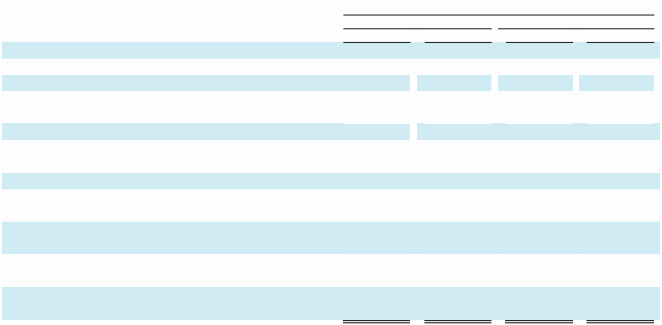

Years Ended December 31,

2022 2023

(In Thousands, Except Per Share Amounts) Class A Class B Class A Class B

Diluted net loss per share:
Numerator:

Net loss applicable to common stockholders Reallocation of net loss for Class A shares as a result of conversion of Class A to Class B shares

Diluted net loss applicable to common stockholders:

$ | (889) |  | $ | (7,356) |  | $ |  | (1,084) |  | $ | (8,826)
 | — |  |  | (889) |  |  |  | — |  |  | (1,084)
$ | (889) |  | $ | (8,245) |  | $ |  | (1,084) |  | $ | (9,910)

Denominator:
Weighted average number of shares outstanding used to
calculate basic net loss per share |  | 4,661 |  |  | 38,560 |  |  |  | 4,661 |  |  | 37,960
Conversion of Class A to Class B common shares
outstanding |  | — |  |  | 4,661 |  |  |  | — |  |  | 4,661
Weighted average number of shares outstanding used to
calculate diluted net loss per share |  | 4,661 |  |  | 43,221 |  |  |  | 4,661 |  |  | 42,621
Diluted net loss per share applicable to common
stockholders | $ | (0.19) |  | $ | (0.19) |  | $ |  | (0.23) |  | $ | (0.23)

48

The computation of diluted net loss per share excludes the following because their effect would be anti-dilutive (in thousands):

For the years ended December 31, 2022 and 2023, outstanding options to acquire 3,766 and 5,367 shares, respectively, of Class B common stock.

For the years ended December 31, 2022 and 2023, 1,105 and 720 shares of unvested Class B restricted common shares, respectively.

For the years ended December 31, 2022 and 2023, 535 and 63 restricted stock units, respectively.

(q) Guarantees

FASB ASC Topic 460, Guarantees provides accounting guidance surrounding liability recognition and disclosure requirements related to guarantees. In the ordinary course of business, the Company is not subject to potential obligations under guarantees that fall within the scope of FASB ASC Topic 460 except for standard indemnification provisions that are contained within many of the Company’s agreements, and give rise only to the disclosure requirements prescribed by FASB ASC Topic 460.

In certain agreements, the Company has agreed to indemnification provisions of varying scope and terms with customers, vendors and other parties with respect to certain matters, including, but not limited to, losses arising out of the Company’s breach of agreements or representations and warranties made by the Company, services to be provided by the Company and intellectual property infringement claims made by third parties. As a result of these provisions, the Company may from time to time provide certain levels of financial support to contract parties to seek to minimize the impact of any associated litigation in which they may be involved. To date, there have been no known events or circumstances that have resulted in any material costs related to these indemnification provisions and no liabilities therefore have been recorded in the accompanying Consolidated Financial Statements. However, the maximum potential amount of the future payments the Company could be required to make under these indemnification provisions could be material.

(r) Recent Accounting Pronouncement Not Yet Effective

In November 2023, the FASB issued ASU 2023-07, Segment Reporting (Topic 280): Improvements to Reportable Segment Disclosures (“ASU 2023-07”), which requires public entities to disclose information about their reportable segments’ significant expenses on an interim and annual basis. In addition, the amendments clarify circumstances in which an entity can disclose multiple segment measures of profit or loss, provides new segment disclosure requirements for entities with a single reportable segment and contains other disclosure requirements. ASU 2023-07 is effective for fiscal years beginning after December 15, 2023 and interim periods within fiscal years beginning after December 15, 2024, with early adoption permitted. The Company is currently assessing the impact of this ASU on its Consolidated Financial Statements.

In December 2023, the FASB issued ASU 2023-09, Income Taxes (Topic 740): Improvements to Income Tax Disclosures ("ASU 2023-09"), which requires public entities to disclose disaggregated information about their effective tax rate reconciliation as well as information on income taxes paid. ASU 2023-09 is effective for annual periods beginning after December 15, 2024 and may be applied on a prospective basis, with early adoption permitted. The Company is currently assessing the impact of this ASU on its Consolidated Financial Statements.

49

Note 2: Property and Equipment

Property and equipment consisted of the following:
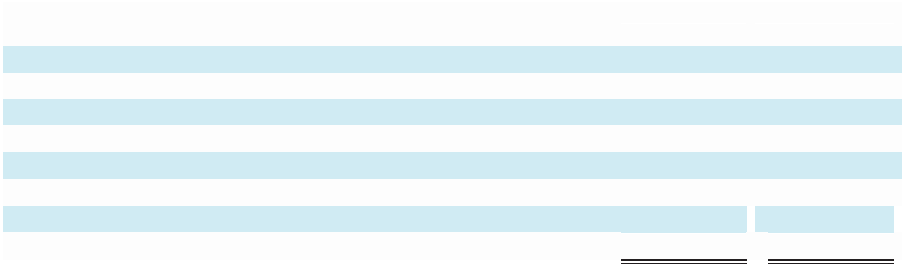

 |  | Years Ended December 31,
(In Thousands) |  | 2022(1) |  |  |  | 2023
Computer and other related equipment | $ | 14,939 |  | $ |  | 1,012
Purchased and internally developed software |  | 3,090 |  |  |  | 2,699
Furniture and fixtures |  | 1,273 |  |  |  | 260
Leasehold improvements |  | 1,732 |  |  |  | —
Construction in progress |  | 1,400 |  |  |  | 25
 | $ | 22,434 |  | $ |  | 3,996
Less: accumulated depreciation and amortization |  | (18,384) |  |  |  | (1,598)
Property and equipment, net | $ | 4,050 |  | $ |  | 2,398

- Includes the original cost of fully depreciated fixed assets which was $13.6 million at December 31, 2022.

Depreciation and amortization expense related to property and equipment was approximately $1.6 million and $1.8 million for the years ended December 31, 2022 and 2023, respectively.

We procured $0.8 million of additional server equipment under new financing lease agreements during the year ended December 31, 2023, with current borrowing of $0.8 million.

Note 3: Leases

The Company has an operating lease for office space for its corporate headquarters in Seattle, Washington which expires on November 30, 2027. The Company’s prior lease agreement with respect to office space in Seattle, Washington, as amended, was terminated by the Company effective on March 31, 2023. In the first quarter of 2023, we paid approximately $671.0 thousand as provided in the lease for the early termination. The Company also has an operating lease for office space in Wichita, Kansas, which continues until December 2025 with an option to extend the term for two additional periods of three years each. The Company has the option to terminate this lease pursuant to certain terms as specified in the lease without any termination fees if notice is provided. The Company recognizes our operating lease agreements in accordance with ASC 842 and recognizes rent expense on a straight-line basis over the lease term with any lease incentives amortized as a reduction of rent expense over the lease term.

Lease cost recognized in the Company’s Consolidated Statements of Operations and other information is summarized as follows:


 |  | Years Ended December 31,
(In Thousands) |  | 2022 |  |  |  | 2023
Operating lease cost | $ | 1,943 |  | $ |  | 1,067
Short-term operating lease cost |  | 202 |  |  |  | 182
Total operating lease cost |  | 2,145 |  |  |  | 1,249
Other information:
Weighted-average remaining lease term - operating leases |  | 1.2 years |  |  |  | 3.6 years
Weighted-average discount rate - operating leases ⁽¹⁾ |  | 4.6% |  |  |  | 6.7%

- The discount rate used to compute the present value of the total lease liabilities as of December 31, 2022 and 2023 was based on the Company’s estimated incremental borrowing rate of similar secured borrowings available to the Company as of the commencement date of lease.

Assets under finance leases, which primarily represent computer equipment, are included in Other assets, net, with the related liabilities included in Lease liability current, and Finance lease, noncurrent on the Company's Consolidated Balance Sheets.

50

As of December 31, 2023 the Company’s operating and financing lease liabilities were as follows:
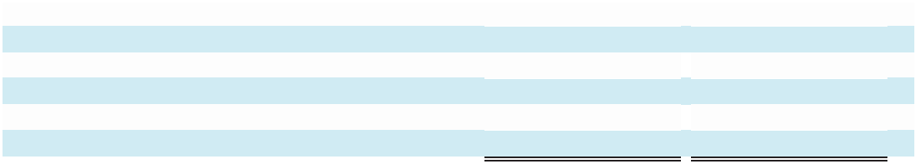

(In Thousands) |  | Operating Leases |  |  | Finance Leases
Gross future lease payments | $ | 1,836 |  | $ | 757
Less: imputed interest |  | (157) |  |  | (95)
Present value of total lease liabilities |  | 1,679 |  |  | 662
Less: current portion of lease liabilities |  | (462) |  |  | (210)
Total long-term lease liabilities | $ | 1,217 |  | $ | 452

In the fourth quarter of 2023, we entered into a rental agreement for utilization of our financed server equipment. We retain our primary obligation under the original financing terms.

Note 4: Commitments and Contingencies

(a) Commitments

The Company has commitments for future payments related to office facilities leases, as well as other contractual obligations primarily related to minimum payments due to outside service providers. The Company leases its office facilities under operating lease agreements in accordance with ASC 842 and recognizes rent expense on a straight-line basis over the lease term with any lease incentive amortized as a reduction of rent expense over the lease term.

Future minimum payments are approximately as follows:
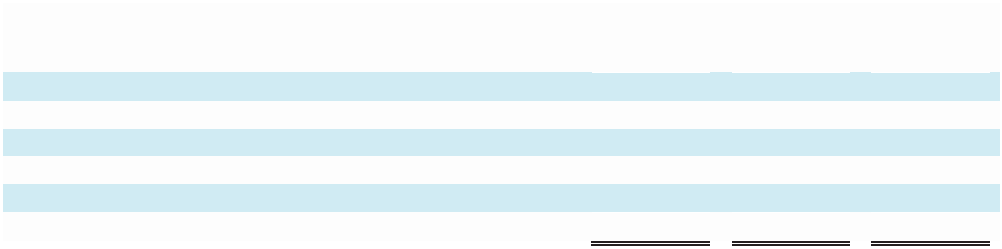

 |  | Facilities |  |  | Other
 |  | operating |  |  | contractual
(In Thousands) |  | leases ⁽¹⁾ |  |  | obligations |  |  |  | Total
2024 |  | 562 |  |  | 1,438 |  |  |  | 2,000
2025 |  | 566 |  |  | 1,235 |  |  |  | 1,801
2026 |  | 397 |  |  | — |  |  |  | 397
2027 |  | 311 |  |  | — |  |  |  | 311
2028 and thereafter |  | — |  |  | — |  |  |  | —
Total minimum payments | $ | 1,836 | $ |  | 2,673 |  | $ |  | 4,509

- For additional information regarding the Company's facilities operating leases, see Note 3. Leases of the Notes to Consolidated Financial Statements for additional information.

(b) Contingencies

In the third quarter of 2021, the Company was legally released from our repayment obligation under CARES Act loans (the "Loans") administered by the U.S. Small Business Administration (“SBA”), as our application for loan forgiveness was approved by the SBA. It is possible that the SBA could subsequently audit the forgiven Loans. The Company believes it was eligible to receive the Loans, calculated the loan amounts correctly, spent loan proceeds on allowable uses and is entitled to loan forgiveness. The Company will retain its financial documents relating to the Loans for six years as required.

The Company from time to time is a party to disputes and legal and administrative proceedings arising from the ordinary course of business. We could become in the future subject to legal proceedings, governmental investigations, and claims in the ordinary course of business, including employment claims, contract-related claims, and claims of alleged infringement of third-party patents, trademarks, and other intellectual property rights. Such claims, even if not meritorious, could force us to expend significant financial and managerial resources and could be material. See (p) Guarantees section of Note 1: Description of Business and Summary of Significant Accounting Policies and Practices of the Notes to Consolidated Financial Statements for additional information

51

On October 21, 2022, the Shareholder Representatives for the former shareholders of Telmetrics, Inc. (an entity acquired by the Company in 2018) filed litigation against the Company in the U.S. District Court for the District of Delaware. The plaintiffs are asserting claims under a share purchase agreement and escrow agreement regarding entitlement to an earnout of up to $3.0 million and $1.0 million that was placed in escrow to secure indemnification obligations. On March 22, 2023, the plaintiffs filed an amended complaint also seeking substantial punitive damages, followed by a second amended complaint on May 9, 2023. On June 7, 2023, the Company filed a motion to compel arbitration and/or dismiss the second amended complaint. The plaintiffs filed a responsive brief on July 5, 2023, and the Company filed a reply brief on July 26, 2023. On February 2, 2024, the Magistrate Judge issued a report and recommendation advising the U.S. District Court Judge to dismiss certain claims from the second amended complaint and to allow other claims to proceed to discovery. The parties filed objections to the report and recommendation on February 16, 2024. While we believe we have meritorious defenses to this lawsuit and are vigorously defending against it, litigation is inherently uncertain and we cannot currently predict the ultimate outcome of this matter.

While any litigation contains an element of uncertainty, the Company is not aware of any legal proceedings or claims which are pending that the Company believes, based on current knowledge, will have, individually or taken together, a material adverse effect on the Company’s financial condition, results of operations or liquidity.

Note 5: Income Taxes

The components of loss before provision for income taxes consist of the following (in thousands):
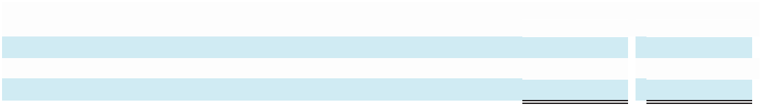

 |  | Years Ended December 31,
(In Thousands) |  | 2022 |  |  |  | 2023
United States | $ | (7,525) |  | $ |  | (9,829)
Foreign |  | (536) |  |  |  | 13
Loss before provision for income taxes | $ | (8,061) |  | $ |  | (9,816)

The provision for income taxes consists of the following (in thousands):
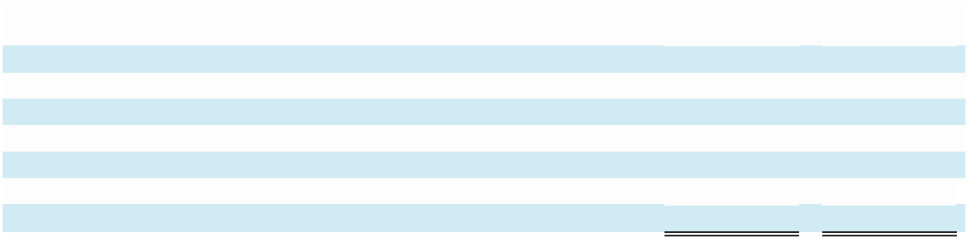

 |  | Years Ended December 31,
(In Thousands) |  | 2022 |  |  | 2023
Current federal provision
State | $ | 58 |  | $ | 78
Foreign |  | 39 |  |  | —
Deferred provision (benefit)
Federal |  | 67 |  |  | 25
State |  | 20 |  |  | (9)
Total income tax expense | $ | 184 |  | $ | 94

52

The Company’s income tax expense differed from the amounts computed by applying the U.S. federal statutory rate to loss before provision for income taxes as a result of the following:
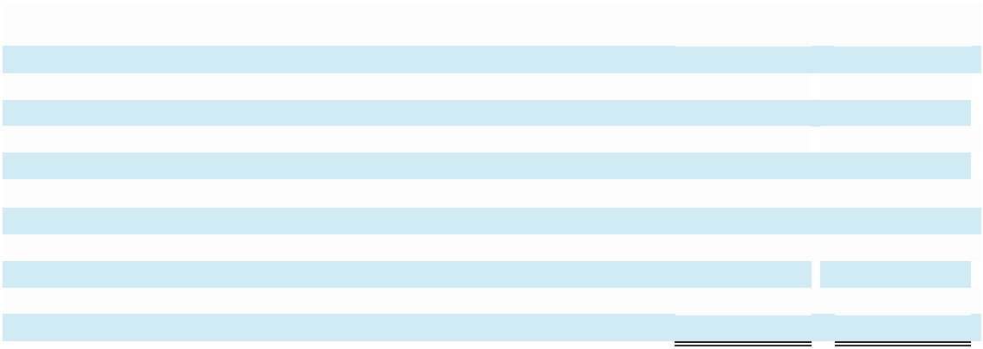

 |  |  | Years Ended December 31,
(In Thousands) |  |  | 2022 |  |  | 2023
.
Income tax benefit at U.S. statutory rate | $ |  | (1,693) |  | $ | (2,061)
State taxes, net of valuation allowance |  |  | 79 |  |  | (339)
Foreign tax differential |  |  | (150) |  |  | 3
Non-deductible transaction costs |  |  | 16 |  |  | (29)
Stock-based compensation ⁽¹⁾ |  |  | 190 |  |  | 101
Gain on CARES Act loan |  |  | 32 |  |  | —
Valuation allowance |  |  | 1,815 |  |  | 2,307
Tax credits |  |  | (237) |  |  | (282)
Other expenses |  |  | 132 |  |  | 394
Total income tax expense | $ |  | 184 |  | $ | 94

- Includes non-deductible stock-based compensation and excess tax benefits and shortfalls from stock-based compensation.

The tax effects of temporary differences that give rise to significant portions of the deferred tax assets and deferred tax liabilities are presented below and reflects the 21% U.S. federal statutory rate for 2022 and 2023 (in thousands):
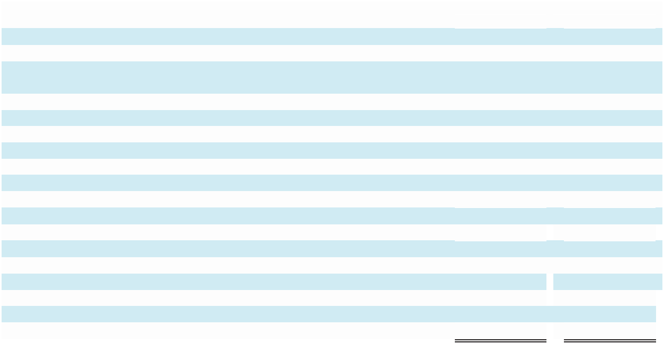

 |  | Years Ended December 31,
(In Thousands) |  | 2022 |  |  | 2023
Deferred tax assets:
Accrued liabilities not currently deductible | $ | 434 |  | $ | 559
Intangible assets- excess of financial statement
over tax amortization |  | 3,341 |  |  | 2,096
Stock-based compensation |  | 675 |  |  | 741
Federal net operating and capital losses |  | 35,724 |  |  | 42,774
State, local and foreign net operating and capital loss carryforwards |  | 5,326 |  |  | —
Research & experimental tax and other credit carryforwards |  | 5,421 |  |  | 5,612
Lease liability |  | 426 |  |  | 416
Capitalized research and development |  | 1,054 |  |  | 1,764
Other |  | 460 |  |  | 337
Gross deferred tax assets |  | 52,861 |  |  | 54,299
Valuation allowance |  | (51,795) |  |  | (54,105)
Net deferred tax assets | $ | 1,066 |  | $ | 194
Deferred tax liabilities:
Intangible assets-excess of tax over financial statement amortization |  | (1,107) |  |  | —
Right-of-use lease asset |  | (192) |  |  | (404)
Other |  | — |  |  | (39)
Net deferred tax liabilities | $ | (233) |  | $ | (249)

As of December 31, 2023, the Company’s federal and state NOL carryforwards were approximately $175.9 million and $60.1 million, respectively. Of the total federal net operating losses reported, we have accumulated $44.2 million with an indefinite life as of December 31, 2023. The remaining federal net operating losses and the state net operating losses will begin to expire in 2027 and 2028, respectively, for income tax purposes. As of December 31, 2023, the Company’s federal research and development credit carryforwards were $4.8 million, which will start expiring in 2029.

53

The Tax Reform Act of 1986 limits the use of NOL and tax credit carryforwards in certain situations where changes occur in the stock ownership of a company. The Company is not aware that any such change has occurred related to these specific tax attributes, or that the utilization of the carryforwards is limited such that these NOL or tax credit carryforwards will likely never be utilized. Accordingly, the Company has included these federal NOL and tax credit carryforwards in its deferred tax assets (subject to valuation allowance).

The Company has recorded a deferred tax asset for stock-based compensation recorded on unexercised non-qualified stock options and certain restricted shares and restricted share units. The ultimate realization of this asset is dependent upon the fair value of the Company’s stock when the options are exercised and when restricted shares or restricted share units vest, and generation of sufficient taxable income to realize the benefit of the related tax deduction.

The Tax Cuts and Jobs Act contained a provision which requires the capitalization of Section 174 costs incurred in years beginning on or after January 1, 2022. Section 174 costs are expenditures which represent research and development costs that are incident to the development or improvement of a product, process, formula, invention, computer software, or technique. This provision changes the treatment of Section 174 costs such that the expenditures are no longer allowed as an immediate deduction but rather must be capitalized and amortized. We have included the impact of this provision, which results in a deferred tax asset of approximately $1.1 million as of December 31, 2022 and $1.8 million as of December 31, 2023.

At December 31, 2022 and 2023, the Company recorded a valuation allowance of $51.8 million, and

$54.1 million, respectively, against its federal, state, city and foreign net deferred tax assets, as it believes it is more

likely than not that these benefits will not be realized. The net change in the total valuation allowance for each of the

years ended December 31, 2022 and 2023 was $(2.3) million and $2.2 million, respectively.

The Company regularly reviews deferred tax assets to assess whether it is more likely than not that the deferred tax assets will be realized and, if necessary, establishes a valuation allowance for portions of such assets to reduce the carrying value. In assessing whether it is more likely than not that the Company’s deferred tax assets will be realized, factors considered included: historical taxable income, historical trends related to customer usage rates, projected revenues and expenses, macroeconomic conditions, issues facing the industry, existing contracts, the Company’s ability to project future results and any appreciation of its other assets. The Company incurred taxable losses from 2016 through 2022. Based on the level of historical taxable losses and the uncertainty of projections for future taxable income over the periods for which the deferred tax assets are deductible, with the exception of certain insignificant foreign deferred tax assets, the Company concluded that it is not more likely than not that the gross deferred tax assets will be realized.

From time to time, various state, federal and other jurisdictional tax authorities undertake audits of the Company and its filings. In evaluating the exposure associated with various tax filing positions, the Company on occasion accrues charges for uncertain positions. Resolution of uncertain tax positions will impact the Company’s effective tax rate when settled. The Company does not have any significant interest or penalty accruals. The provision for income taxes includes the impact of contingency provisions and changes to contingencies that are considered appropriate. The following table summarizes activity related to tax contingencies from January 1, 2022 to December 31, 2023 which are recorded as an offset to deferred tax assets (in thousands):
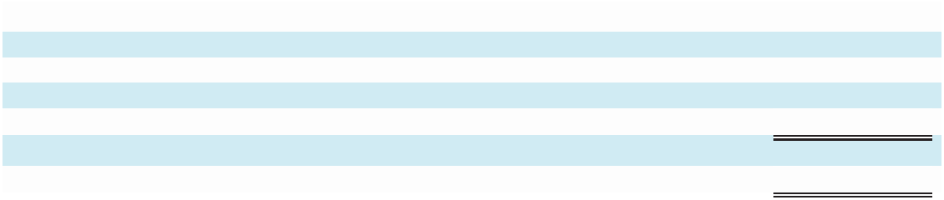

(In Thousands)
Gross tax contingencies—January 1, 2022 | $ | 1,382
Gross increases to current period tax positions |  | 2
Gross decreases to tax positions associated with prior periods |  | —
Gross tax contingencies—December 31, 2022 |  | 1,384
Gross increases to current period tax positions |  | 25
Gross tax contingencies—December 31, 2023 | $ | 1,409

The Company files U.S. federal, certain U.S. states, and certain foreign tax returns. Generally, U.S. federal, U.S. state, and foreign tax returns filed for years after 2013 are within the statute of limitations and are under examination or may be subject to examination.

54

Note 6: Stockholders' Equity

(a) Common Stock and Authorized Capital

The total number of shares of all classes of capital stock which the Company has authority to issue is 138,500,000 shares, consisting of (i) 137,500,000 shares of common stock, par value $.01 per share, of which 12,500,000 shares are designated Class A common stock and 125,000,000 shares are designated Class B common stock, and (ii) 1,000,000 shares of preferred stock, par value $.01 per share. The Company’s board of directors has the authority to designate rights, privileges and restrictions of each such series, including dividend rights, dividend rates, conversion rights, voting rights, terms of redemption, redemption prices, liquidation preferences and the number of shares constituting any series.

The Company has two classes of authorized common stock: Class A common stock and Class B common stock. Except with respect to voting rights, the Class A and Class B shares have identical rights. Each share of Class A common stock is entitled to twenty-five votes per share, and each share of Class B common stock is entitled to one vote per share. Each share of Class A common stock is convertible at the holder’s option into one share of Class B common stock.

In accordance with the stockholders’ agreement signed by the founding Class A common stockholders, the following provisions survived the Company’s initial public offering: Class A stockholders other than Russell C. Horowitz may only sell, assign or transfer their Class A stock to existing Class A stockholders or to the Company and in the event of transfers of Class A stock not expressly permitted by the stockholders’ agreement, such shares of Class A stock shall be converted into shares of Class B common stock.

In November 2014, the Company’s board of directors authorized a new share repurchase program (the “2014 Repurchase Program”), which supersedes and replaces any prior repurchase programs. Under the 2014 Repurchase Program, the Company is authorized to repurchase up to 3,000,000 shares of the Company’s Class B common stock in the aggregate through open market and privately negotiated transactions, at such times and in such amounts as the Company deems appropriate. Repurchases may also be made under a Rule 10b5-1 plan, which would permit shares to be repurchased when the Company might otherwise be precluded from doing so under insider trading laws. The timing and actual number of shares repurchased will depend on a variety of factors including price, corporate and regulatory requirements, capital availability, and other market conditions. The 2014 Repurchase Program does not have an expiration date and may be expanded, limited or terminated at any time without prior notice. The Company has made no repurchases under the 2014 Repurchase Program for the years ended December 31, 2022 and 2023. Shares repurchased but not yet retired by the Company are classified as treasury stock on the Consolidated Balance Sheet before retirement. Retirement of treasury stock results in reductions to common stock and additional paid-in capital.

In November 2018, the Company acquired 100% of the outstanding stock of Callcap for consideration of approximately $25.0 million in cash at closing and approximately 3,400,000 shares of Class B common stock to be issued over the four year period following the acquisition date. The issuance of the shares for 2021 and 2022 was deferred as a result of conditional events occurring as specified in terms of the acquisition. In 2022, we paid $1.5 million in cash and agreed to transfer $335.0 thousand in cash and/or equipment before November 2023 in exchange for settling our contractual obligation to issue 1,340,000 of such shares. The $1.5 million cash consideration was recognized as a financing activity on our Consolidated Statements of Cash Flow for the year ended December 31, 2022. In October 2023, the Company settled its $335.0 thousand obligation by transferring equipment with a book value of $593.0 thousand and receiving $65.0 thousand in cash, which resulted in a loss of approximately $193.0 thousand that was recognized within Interest income (expense) and other, net on the Consolidated Statements of Operations for the year ended December 31, 2023, and as a combination of non-cash activity and proceeds from sales of fixed assets on our Consolidated Statements of Cash Flow for the year ended December 31, 2023. The remaining shares issuable for the Callcap acquisition were issued in December 2023.

In December 2019, the Company acquired 100% of the outstanding stock of Sonar for consideration of approximately $8.5 million in cash at closing and approximately 1,000,000 shares of Class B common stock to be issued over the three-year period following the acquisition date, which have been issued in their entirety. The Company also agreed to issue up to approximately 389,000 shares of Class B common stock based upon the achievement of certain financial target goals by Sonar in 2020 which were not achieved.

55

(b) Stock Option Plan

The Company’s stock incentive plan (the “2021 Plan”), which was established in 2021, allows for grants of stock options, restricted stock units and restricted stock awards to eligible participants and such options may be designated as incentive or non-qualified stock options at the discretion of the 2021 Plan’s Administrative Committee. Prior to the 2021 Plan, the Company granted stock-based awards under its 2012 Stock Incentive Plan (the “2012 Plan”). No further awards were made under the 2012 Plan after December 31, 2021. The 2021 Plan authorizes up to 3,500,000 shares of Class B common stock that may be issued with respect to awards granted under the 2021 Plan, and provides that the total number of shares of Class B common stock for which options designated as incentive stock options may be granted shall not exceed 3,500,000 shares. Annual increases to each of these share limits are to be added on the first day of each fiscal year beginning on January 1, 2022 equal to 3% of the outstanding common stock (including for this purpose any shares of common stock issuable upon conversion of any outstanding capital stock of the Company) or in the case of incentive stock options, the lesser of (i) 2,000,000 shares of Class B common stock, or (ii) 3% of the outstanding common stock (including for this purpose any shares of common stock issuable upon conversion of any outstanding capital stock of the Company), or (iii) such number as determined by the Company’s board of directors. As a result of this provision, the authorized number of shares available under the 2021 Plan was increased by 1,261,566 and 1,294,725 on January 1, 2022 and 2023, respectively, bringing the aggregate authorized number of shares available under the 2021 Plan to 6,056,291. The Company may issue new shares or reissue treasury shares for stock option exercises and restricted stock grants. Generally, stock options have 10-year terms and vest 25% each year either annually or quarterly, over a 4-year period and restricted stock awards and units vest 25% each year annually over a 4-year period.

The Company did not grant any options with exercise prices less than the then current market value during 2022 and 2023.

The Company measures stock-based compensation cost at the grant date based on the fair value of the award and recognizes it as expense over the vesting or service period, as applicable, of the stock award using the straight-line method. The Company accounts for forfeitures as they occur. Stock-based compensation has been included in the same lines as compensation paid to the same employees in the Consolidated Statements of Operations.

Stock-based compensation expense was included in the following operating expense categories:


 |  | Years Ended December 31,
(In Thousands) |  | 2022 |  |  | 2023
Service costs | $ | 171 |  | $ | 2
Sales and marketing |  | 796 |  |  | 663
Product development |  | 293 |  |  | 114
General and administrative |  | 1,386 |  |  | 1,613
Total stock-based compensation | $ | 2,646 |  | $ | 2,392

Stock-based compensation expense as reported in the Consolidated Statements of Operations for the year ended December 31, 2023, varies from the reported Stock-based compensation from options and restricted stock, net of forfeitures in the Consolidated Statements of Stockholders’ Equity for the year ended December 31, 2023, because of a reclassification of a $750.0 thousand payment owed to a former employee in connection with the Sonar acquisition. This payment was to be made, at the Company's election, in any mix of cash or restricted stock. The Company had previously determined its intent and ability to settle this obligation in restricted stock; however, in December 2023, the Company chose to settle in cash, resulting in a reclassification of this payment obligation from Additional paid-in capital to Other accrued expenses and current liabilities in the Consolidated Statements of Balance Sheets. This caused a decrease to Stock-based compensation from options and restricted stock, net of forfeitures in the Consolidated Statements of Stockholders’ Equity, with no corresponding decrease in stock-based compensation as reported in the Consolidated Statements of Operations, for the year ended December 31, 2023.

For the years ended December 31, 2022 and 2023, the income tax benefit related to stock-based compensation included in net loss was $– million for all periods due to the valuation allowance recorded on the deferred tax assets.

56

The Company uses the Black-Scholes option pricing model to estimate the per share fair value of stock option grants with time-based vesting. The Black-Scholes model relies on a number of key assumptions to calculate estimated fair values. For years ended December 31, 2022 and 2023, the expected life of each award granted was determined based on historical experience with similar awards, giving consideration to contractual terms, anticipated exercise patterns, and vesting schedules. Expected volatility is based on historical volatility levels of the Company’s Class B common stock and the expected volatility of companies in similar industries that have similar vesting and contractual terms. The risk-free interest rate is based on the implied yield currently available on U.S. Treasury issues with terms approximately equal to the expected life of the option. The Company uses an expected annual dividend yield in consideration of the Company’s common stock dividend payments, which we consider to be zero.

The following assumptions were used in determining the fair value of time-vested stock options granted for the periods indicated:


 | Years Ended December 31,
 | 2022 |  | 2023
Expected life (in years) | 4.00 - 6.25 | 4.00 - 6.25
Risk-free interest rate | 2.41% - 4.30% | 3.86% - 3.93%
Expected volatility | 51% - 63% | 57% - 64%
Weighted average expected volatility | 55% | 57%

Stock option, restricted stock award, and restricted stock unit activity during the period is as follows:
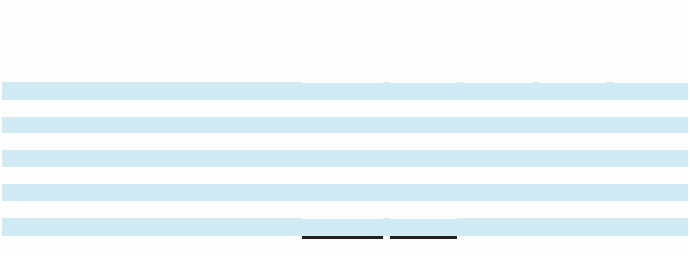

 |  |  |  |  |  |  | Weighted
 | Options and |  | Number of |  | Weighted |  | average |  | Aggregate
 | Restricted |  | options |  | average |  | remaining |  | Aggregate
 | Stock available |  | outstanding |  | exercise |  | contractual |  | intrinsic
 | for grant |  | (in |  | price |  | term |  | value
 | (in thousands) |  | thousands) |  | of options |  | (in years) |  | (in thousands)
Balance at December 31, 2022 | 16,599 |  | 3,796 |  | $3.14 |  | 6.67 | $10
Increase to pool January 1, 2023 | 1,300
Options granted | (3,299) |  | 3,328 |  | $1.67
Restricted stock granted | (333) |  | —
Restricted stock forfeited | 656 |  | —
Options exercised | — |  | —
Options expired | 1,115 |  | (1,115) |  | $3.62
Options forfeited | 614 |  | (614) |  | $2.49
Balance at December 31, 2023 | 16,652 |  | 5,395 |  | $2.21 |  | 7.39 | $1
Options exercisable at December 31, 2023 |  |  | 1,674 |  | $3.31 |  | 5.40 | $1

Information related to stock compensation activity during the period indicated is as follows:
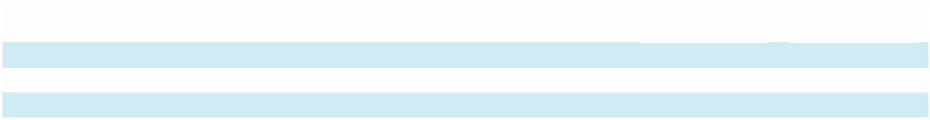

 |  |  | Years Ended December 31,
 |  |  | 2022 |  |  | 2023
Weighted average fair value of options granted | $ |  | 1.06 | $ |  | 0.92
Intrinsic value of options exercised (in thousands) | $ |  | —
Total grant date fair value of restricted stock vested (in thousands) | $ |  | 1,321 | $ |  | 3,037

At December 31, 2023, there was $2.8 million of unrecognized stock option compensation expense related to non-vested awards, which is expected to be recognized over a weighted average period of 3.3 years.

57

Restricted stock awards and restricted stock unit activity during the period is as follows:
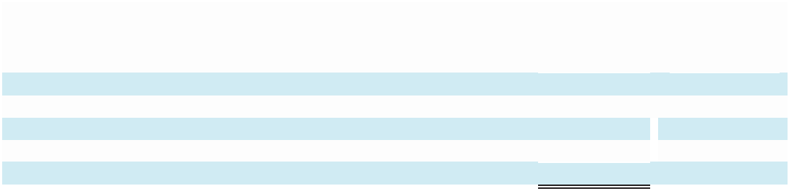

 |  |  |  |  | Weighted
 | Shares/ |  |  |  | Average
 | Units |  |  |  | Grant Date
 | (In Thousands) |  |  |  | Fair Value
Unvested at December 31, 2022 | 1,640 |  | $ |  | 2.27
Granted | 333 |  |  |  | 1.84
Vested | (535) |  |  |  | 2.33
Forfeited | (656) |  |  |  | 2.61
Unvested at December 31, 2023 | 782 |  |  |  | 1.94

Restricted stock awards and restricted stock units are generally measured at fair value on the date of grant based on the number of awards granted and the quoted price of the Company’s common stock. Restricted stock awards and restricted stock units are expensed on a straight-line basis over the vesting or service period, as applicable, and forfeitures are recognized as they occur. Restricted stock units entitle the holder to receive one share of the Company’s Class B common stock upon satisfaction of certain service conditions.

At December 31, 2023, there was $0.8 million of unrecognized restricted stock compensation expense related to non-vested restricted stock, which is expected to be recognized over a weighted average period of 2.0 years.

(c) Employee Stock Purchase Plan

On March 8, 2013, the Company’s board of directors adopted and in May 2013 the stockholders approved the

2014 Employee Stock Purchase Plan (“2014 ESPP”), which became effective on January 1, 2014. The Company authorized an aggregate of 225,000 shares of Class B common stock for issuance under the plan to participating employees. The 2014 ESPP, which expired on December 31, 2023, provided eligible employees the opportunity to purchase the Company’s Class B common stock at a price equal to 95% of the closing price on the last business day of each purchase period. The 2014 ESPP permitted eligible employees to purchase amounts up to 15% of their compensation in the purchase period, and no employee was permitted to purchase stock worth more than $25,000 in any calendar year, valued as of the first day of each purchase period. During the year ended December 31, 2022, 18,721 shares were purchased at prices ranging from $1.25 to $2.18 per share. During the year ended December 31, 2023, 15,174 shares were purchased at prices ranging from 1.29 to 2.01 per share.

Note 7: 401(k) Savings Plan

The Company maintains voluntary defined contribution plans, which are qualified, covering employees that meet eligibility requirements. Eligible employees may elect to defer and contribute a portion of their eligible compensation to the plans, not to exceed the dollar amounts set by applicable laws. In 2022 and 2023, cash contributions were made in the amount of $0.2 million and $0.2 million respectively.

Note 8: Segment Reporting and Geographic Information

Operating segments are revenue-producing components of the enterprise for which separate financial information is produced internally for the Company’s management. For the years ended December 31, 2022 and 2023, the Company operated in a single segment comprised of its conversational analytics and related solutions.

Long-lived assets by geographical region are based on the location of the legal entity that owns the assets. As of December 31, 2022 and 2023, no significant long-lived assets were held by entities outside of the United States.

Revenues from customers by geographical areas are tracked on the basis of the location of the customer. The majority of the Company’s revenue and accounts receivable are derived from domestic sales to customers.

58

Revenues by geographic region are as follows:
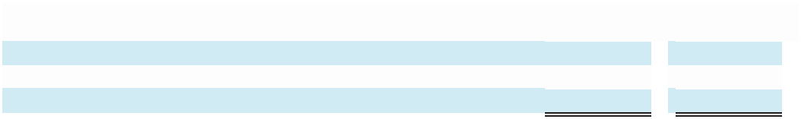

 | Years ended December 31,
(In Percentages) | 2022 |  | 2023
United States | 99% |  | 99%
Canada and other countries | 1% |  | 1%
Total | 100% |  | 100%

Note 9: Identified Intangible Assets

Identifiable intangible assets from acquisitions consisted of the following:
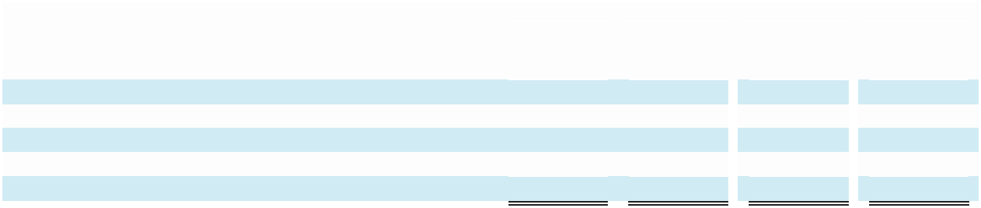

 |  |  |  |  | As of December 31, 2022
 |  | Gross
 |  | Carrying |  | Accumulated |  |  |  |  |  | Net Carrying
(In Thousands) |  | Amount |  | Amortization |  |  | Impairment |  |  |  | Amount
Customer relationships | $ | 13,018 | $ |  | (8,202) |  | $ | (3,430) |  | $ | 1,386
Technologies |  | 9,369 |  |  | (7,372) |  |  | (1,062) |  |  | 935
Non-compete agreements |  | 3,409 |  |  | (2,794) |  |  | (346) |  |  | 269
Trade names |  | 734 |  |  | (613) |  |  | (121) |  |  | —
Total identifiable intangible assets from acquisitions | $ | 26,530 |  | $ | (18,981) |  | $ | (4,959) |  | $ | 2,590
 |  |  |  |  | As of December 31, 2023
 |  | Gross
 |  | Carrying |  | Accumulated |  |  |  |  |  | Net Carrying
(In Thousands) |  | Amount |  | Amortization |  |  | Impairment |  |  |  | Amount
Customer relationships | $ | 13,018 | $ |  | (9,588) |  | $ | (3,430) |  | $ | —
Technologies |  | 9,369 |  |  | (7,839) |  |  | (1,062) |  |  | 468
Non-compete agreements |  | 3,409 |  |  | (2,929) |  |  | (346) |  |  | 134
Trade names |  | 734 |  |  | (613) |  |  | (121) |  |  | —
Total identifiable intangible assets from acquisitions | $ | 26,530 |  | $ | (20,969) |  | $ | (4,959) |  | $ | 602
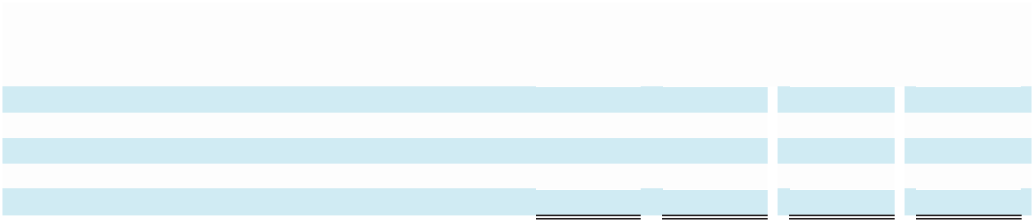

Amortizable intangible assets are amortized on a straight-line basis over their useful lives. Customer relationships, acquired technologies, trade names, and non-compete agreements have a weighted average useful life from date of purchase of 5 years, 3-5 years, 2 years, 1 - 3 years, respectively. Aggregate amortization expense incurred by the Company for the year ended December 31, 2022 and 2023 was approximately $2.1 million and $2.0 million, respectively. The entire remaining net carrying amount of acquired identifiable intangible assets subject to amortization as of December 31, 2023, will be fully amortized within the next year, resulting in estimated amortization expense of $0.6 million in 2024.

Note 10: Divestiture Support Services Agreement

In October 2020, the Company sold certain assets related to its Local Leads Platform, Call Marketplace and other assets not related to core conversational analytics. The purchaser was a related party controlled by a shareholder and officers of the Company. In connection with the closing, the Company also entered into an administrative support services agreement with the related party purchaser pursuant to which the Company was to provide services to the related party purchaser for a support services fee, with certain guaranteed payments to the Company in the first year and in the second year following closing. Support services fees related to this arrangement totaled $6.4 million for the year ended December 31, 2022 and $1.5 million for the year ended December 31, 2023 are included in the Company’s Consolidated Statements of Operations, net of the related expenses, within Service costs, Sales and marketing, Product development, and General and administrative. As of December 31, 2022 and 2023, the net amount due from the purchaser of $0.7 million and $0.4 million respectively, is included in the Company’s Consolidated Balance Sheet within Prepaid expenses and other current assets.

59

Note 11: Interest income (expense) and other, net

Interest income (expense) and other, net consists of the following (in thousands):
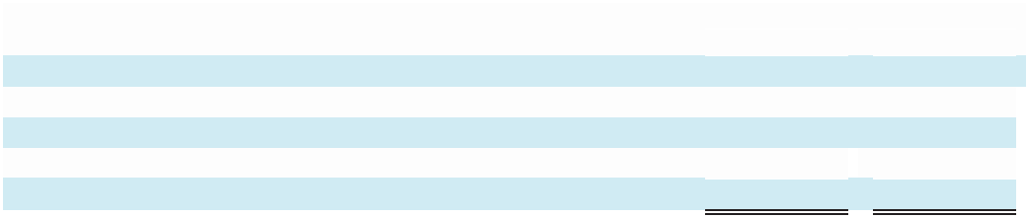

 | Years Ended December 31,
 | 2022 |  |  |  | 2023
Interest Income | $ | 97 |  | $ | 319
Interest Expense |  | — |  |  | (282)
Foreign Currency |  | 2 |  |  | (11)
Other |  | (11) |  |  | (199)
Total | $ | 88 |  | $ | (173)

60

ITEM 9. CHANGES IN AND DISAGREEMENTS WITH ACCOUNTANTS ON ACCOUNTING AND FINANCIAL DISCLOSURE.

None.

ITEM 9A. CONTROLS AND PROCEDURES.

Evaluation of Disclosure Controls and Procedures

As of the end of the period covered by this report, we carried out an evaluation, under the supervision and with the participation of our principal executive officer and our principal financial officer, of the effectiveness of our “disclosure controls and procedures” (as defined in Rules 13a-15(e) and 15d-15(e) of the Securities Exchange Act of 1934). Based on this evaluation, our principal executive officer and our principal financial officer has concluded that, as of the date of the evaluation, our disclosure controls and procedures were effective.

Management’s Report on Internal Control Over Financial Reporting

(a) Management’s report on internal control over financial reporting

Management of Marchex, Inc. is responsible for establishing and maintaining adequate internal control over financial reporting, as such term is defined in the Securities Exchange Act of 1934 Rule 13a-15(f). Under the supervision and with the participation of our management, including our principal executive officer and principal financial officer, we conducted an evaluation of the effectiveness of our internal control over financial reporting as of December 31, 2023as required by the Securities Exchange Act of 1934 Rule 13a-15(c). In making this assessment, we used the criteria set forth in the framework in Internal Control-Integrated Framework issued by the Committee of Sponsoring Organizations of the Treadway Commission (2013 framework). Based on our evaluation, our management concluded that our internal control over financial reporting was effective as of December 31, 2023.

Limitations on the Effectiveness of Controls

In designing and evaluating the disclosure controls and procedures, management recognizes that any controls and procedures, no matter how well designed and operated, cannot provide absolute assurance of achieving the desired control objectives.

In addition, because of its inherent limitations, internal control over financial reporting may not prevent or detect misstatements. Also, projections of any evaluation of effectiveness to future periods are subject to the risk that controls may become inadequate because of changes in conditions, or that the degree of compliance with the policies or procedures may deteriorate.

ITEM 9B. OTHER INFORMATION.

Securities Trading Plans of Directors and Executive Officers

During the last fiscal quarter of 2023, the following executive officer adopted a “Rule 10b5-1 trading arrangement,” as defined in Regulation S-K Item 408, as follows:

On November 15, 2023, Edwin Miller, Chief Executive Officer of Marchex, adopted a Rule 10b5-1 trading arrangement providing for the purchase during open trading windows of up to $50,000 of shares of Class B common stock. The trading arrangement is intended to satisfy the affirmative defense in Rule 10b5-1(c). The duration of the trading arrangement is until November 29, 2024 or earlier if all transactions under the trading arrangement are completed.

61

No other directors or officers, as defined in Rule 16a-1(f), have adopted and/or terminated a “Rule 10b5-1 trading arrangement” or a “non-Rule 10b5-1 trading arrangement,” each as defined in Regulation S-K Item 408, during the last fiscal quarter.

Policy for Recovery of Incentive Compensation

On November 28, 2023, the Board of Directors of Marchex adopted a Policy for Recovery of Incentive Compensation filed herewith as Exhibit 97.1.

62

PART III

ITEM 10. DIRECTORS, EXECUTIVE OFFICERS AND CORPORATE GOVERNANCE.

The information required by this item is incorporated herein by reference to the Company’s definitive proxy statement relating to the 2024 annual meeting of stockholders (the “2024 Proxy Statement”), or an amendment to this 10-K, to be filed with the Securities and Exchange Commission (“SEC”) within 120 days of the Company’s fiscal year ended December 31, 2023.

Our Code of Ethics for our Chief Executive Officer, Chief Financial Officer and Senior Financial Officers is available on our web site, www.marchex.com, by clicking “Investors” and then “Corporate Governance”.

ITEM 11. EXECUTIVE COMPENSATION.

The information required under this item may be found in the 2024 Proxy Statement and is incorporated herein by reference, or an amendment to this 10-K, to be filed with the SEC within 120 days of the Company’s fiscal year ended December 31, 2023.

ITEM 12. SECURITY OWNERSHIP OF CERTAIN BENEFICIAL OWNERS AND MANAGEMENT AND RELATED STOCKHOLDER MATTERS.

The information required under this item may be found in the 2024 Proxy Statement and is incorporated herein by reference, or an amendment to this 10-K, to be filed with the SEC within 120 days of the Company’s fiscal year ended December 31, 2023.

ITEM 13. CERTAIN RELATIONSHIPS AND RELATED TRANSACTIONS, AND DIRECTOR INDEPENDENCE.

The information required under this item may be found in the 2024 Proxy Statement and is incorporated herein by reference, or an amendment to this 10-K, to be filed with the SEC within 120 days of the Company’s fiscal year ended December 31, 2023.

ITEM 14. PRINCIPAL ACCOUNTING FEES AND SERVICES.

The Company’s independent registered public accounting firm is RSM US LLP, Seattle, WA, PCAOB ID: 49.

The information required under this item may be found in the 2024 Proxy Statement and is incorporated herein by reference, or an amendment to this 10-K, to be filed with the SEC within 120 days of the Company’s fiscal year ended December 31, 2023.

63

PART IV

ITEM 15. EXHIBITS, FINANCIAL STATEMENT SCHEDULES.

- The following reports and financial statements are included in Part II, Item 8 of this Form 10-K:

Report of Independent Registered Public Accounting Firm;

Consolidated Balance Sheets as of December 31, 2022 and 2023;

Consolidated Statements of Operations for the years ended December 31, 2022 and 2023;

Consolidated Statements of Stockholders’ Equity for the years ended December 31, 2022 and 2023;

Consolidated Statements of Cash Flow for the years ended December 31, 2022 and 2023; and

Notes to Consolidated Financial Statements.

- Financial Statement Schedules

Financial statement schedules are omitted because they are not required or are not applicable, or the required information is provided in the Consolidated Financial Statements or notes described in Item 15 (1) above.

- We have filed, or incorporated into this Form 10-K by reference, the exhibits listed on the accompanying Exhibit Index immediately following the signature page of this Form 10-K.

64

EXHIBIT INDEX

Exhibit Number Description of Document

++2.1 Share Purchase Agreement, dated as of November 5, 2018, by and among the Registrant, Marchex

CA Corporation, Telmetrics Inc., the Sellers and with respect to Articles I and IX only, the Stockholder Representatives (incorporated by reference to Exhibit 2.5 to the Registrant’s Annual Report on Form 10-K for the fiscal year ended December 31, 2018 filed with the SEC on March 18, 2019).

++2.2 Share Purchase Agreement, dated as of November 20, 2018, by and among the Registrant, Sita Laboratories, Inc., the Sellers and the Stockholder Representative (incorporated by reference to Exhibit 2.6 to the Registrant’s Annual Report on Form 10-K for the fiscal year ended December 31, 2018 filed with the SEC on March 18, 2019).

+2.3 Equity Purchase Agreement, dated as of December 13, 2019, by and among the Registrant, Sonar Technologies, Inc., the Sellers and Fortis Advisers LLC, as Securityholder Representative (incorporated by reference to Exhibit 2.7 to the Registrant’s Annual Report on Form 10-K for the fiscal year ended December 31, 2019 filed with the SEC on March 13, 2020).

2.4 Asset Purchase Agreement, dated August 7, 2020, between the Company and Archenia, Inc. (incorporated by reference to Annex A of the Proxy Statement, as filed with the SEC on August 24, 2020).

2.5 Support Services Agreement, dated October 16, 2020, between the Company and Archenia, Inc. (incorporated by reference to Annex A of the Proxy Statement, as filed with the SEC on August 24, 2020).

3.1 Amended and Restated Certificate of Incorporation of the Registrant (incorporated by reference to Exhibit 3.3 to the Registrant’s Amendment No. 2 to the Registration Statement on Form SB-2 (No. 333-111096) filed with the SEC on March 19, 2004).

3.2 Second Amended and Restated By-Laws of the Registrant (incorporated by reference to Exhibit

3.3 to the Registrant’s Quarterly Report on Form 10-Q filed with the SEC on November 6, 2017).

4.1 Specimen stock certificate representing shares of Class B Common Stock of the Registrant (incorporated by reference to Exhibit 4.1 to the Registrant’s Amendment No. 3 to the Registration Statement on Form SB-2 (No. 333-111096) filed with the SEC on March 30, 2004).

*10.1 Form of Retention Agreement (incorporated by reference to Exhibit 10.2 to the Registrant’s Annual Report on Form 10-K for the fiscal year ended December 31, 2017 filed with the SEC on March 14, 2018).

*10.2 Form of First Amendment to Retention Agreement (incorporated by reference to Exhibit 10.13 to the Registrant’s Annual Report on Form 10-K for the fiscal year ended December 31, 2014 filed with the SEC on March 10, 2015).

*10.3 Revised Form of Retention Agreement (incorporated by reference to Exhibit 10.14 to the Registrant’s Annual Report on Form 10-K for the fiscal year ended December 31, 2014 filed with the SEC on March 10, 2015).

10.4 Amended and Restated Lease effective as of June 5, 2009, between 520 Pike Street, Inc. and the Registrant (incorporated by reference to Exhibit 10.19 to the Registrant’s Annual Report on Form 10-K for the fiscal year ended December 31, 2014 filed with the SEC on March 10, 2015).

*10.5 Marchex, Inc. Amended and Restated Annual Incentive Plan (incorporated by reference to Exhibit

10.14 to the Registrant’s Annual Report on Form 10-K for the fiscal year ended December 31,

2016 filed with the SEC on March 8, 2017).

65

Exhibit Number Description of Document

*10.6 Marchex, Inc. 2012 Stock Incentive Plan (incorporated by reference to Appendix A to the Registrant’s Definitive Proxy Statement on Form 14A filed with the SEC on July 10, 2017).

*10.7 Marchex, Inc. 2014 Employee Stock Purchase Plan (incorporated by reference to Exhibit 10.14 to the Registrant’s Annual Report on Form 10-K for the fiscal year ended December 31, 2018 filed with the SEC on March 18, 2019).

*10.8 Form of Incentive Stock Option Notice and Agreement (2012 Stock Incentive Plan) (incorporated by reference to Exhibit 10.15 to the Registrant’s Annual Report on Form 10-K for the fiscal year ended December 31, 2018 filed with the SEC on March 18, 2019).

*10.9 Form of Nonstatutory Stock Option Notice and Agreement (2012 Stock Incentive Plan) (incorporated by reference to Exhibit 10.16 to the Registrant’s Annual Report on Form 10-K for the fiscal year ended December 31, 2018 filed with the SEC on March 18, 2019).

*10.10 Form of Restricted Stock Agreement (2012 Stock Incentive Plan) (incorporated by reference to Exhibit 10.17 to the Registrant’s Annual Report on Form 10-K for the fiscal year ended December 31, 2018 filed with the SEC on March 18, 2019).

*10.11 Form of Restricted Stock Units Notice and Agreement (2012 Stock Incentive Plan) (incorporated by reference to Exhibit 10.18 to the Registrant’s Annual Report on Form 10-K for the fiscal year ended December 31, 2018 filed with the SEC on March 18, 2019).

*10.12 Form of Indemnity Agreement (Section 16 Executive Officers and Directors) (incorporated by reference to Exhibit 10.20 to the Registrant’s Annual Report on Form 10-K for the fiscal year ended December 31, 2018 filed with the SEC on March 18, 2019).

*10.13 Amended and Restated Executive Employment Agreement effective as of April 21, 2016, by and between Michael Arends and the Registrant (incorporated by reference to Exhibit 10.50 to the Registrant’s Quarterly Report on Form 10-Q filed with the SEC on August 9, 2016).

10.14 Amendment No. 3 to Amended and Restated Lease dated June 27, 2017, between 520 Pike Street, Inc. and the Registrant (incorporated by reference to Exhibit 10.46 to the Registrant’s Quarterly Report on Form 10-Q filed with the SEC on August 4, 2017).

*10.15

*10.16

*10.17

*10.18

*10.19

Marchex, Inc. 2021 Stock Incentive Plan (incorporated by reference to Appendix A to the Registrant’s Definitive Proxy Statement on Form 14A filed with the SEC on August 20, 2021).

Form of Incentive Stock Option Notice and Agreement (2021 Stock Incentive Plan).

Form of Nonstatutory Stock Option Notice and Agreement (2021 Stock Incentive Plan).

Form of Restricted Stock Agreement (2021 Stock Incentive Plan).

Form of Restricted Stock Units Notice and Agreement (2021 Stock Incentive Plan).

10.20 Sublease effective as of January 5, 2023, between the Board of Regents of the University of Washington and the Registrant (incorporated by reference to Exhibit 10.25 to the Registrant’s Annual Report on Form 10-K filed with the SEC on March 31, 2023)

*10.21 Independent Contractor Agreement dated February 3, 2023 by and between Russell C. Horowitz and the Registrant (incorporated by reference to Exhibit 10.26 to the Registrant’s Quarterly Report on Form 10-Q filed with the SEC on May 5, 2023)

66

Exhibit Number

†21.1

†23.1

24.1

†31.1(i)

†31.1(ii)

††32

Description of Document

Subsidiaries of the Registrant.

Consent of RSM US LLP

Power of Attorney (incorporated herein by reference to the signature page of the Annual Report on Form 10-K)

Certification of Principal Executive Officer pursuant to Rule 13a-14(a)/15d-14(a) as Adopted Pursuant to Section 302 of the Sarbanes-Oxley Act of 2002.

Certification of Principal Financial Officer pursuant to Rule 13a-14(a)/15d-14(a) as Adopted Pursuant to Section 302 of the Sarbanes-Oxley Act of 2002.

Certification of Principal Executive Officer and Principal Financial Officer Pursuant to 18 U.S.C.

Section 1350, as Adopted Pursuant to Section 906 of the Sarbanes-Oxley Act of 2002.

†97.1 Policy for Recovery of Executive Compensation
†_{101. INS} Inline XBRL Instance Document – the instance document does not appear in the Interactive Data File because XBRL tags are embedded within the Inline XBRL document.

†_{101.SCH} Inline XBRL Taxonomy Extension Schema With Embedded Linkbase Documents. 104 Cover Page Interactive Data File (embedded within the Inline XBRL document)

*Management contract or compensatory plan or arrangement.

- Certain identified information has been excluded from this Agreement because it is both (i) not material and (ii) would be competitively harmful if publicly disclosed.

(+)(+) Certain information in this Agreement has been omitted and filed separately with the SEC. Confidential treatment has been granted with respect to the omitted portions.

† Filed herewith.

†† Furnished herewith.

67

SIGNATURES

Pursuant to the requirements of Section 13 or 15(d) of the Securities Exchange Act of 1934, the Registrant has duly caused this report to be signed on its behalf by the undersigned, thereunto duly authorized in the City of Seattle, State of Washington on March 29, 2024.

MARCHEX, INC.

By: /S/ Holly A. Aglio

Chief Financial Officer

(Principal Financial Officer and Principal

Accounting Officer)

POWER OF ATTORNEY

KNOW ALL PERSONS BY THESE PRESENTS, that each person whose signature appears below constitutes and appoints Holly A. Aglio, as his attorney-in-fact, with the full power of substitution, for him, in any and all capacities, to sign any amendment to this Annual Report on Form 10-K, and to file the same, with exhibits thereto and other documents in connection therewith, with the Securities and Exchange Commission, granting to said attorney-in-fact, and with full power and authority to do and perform each and every act and thing requisite and necessary to be done in connection therewith, as fully to all intents and purposes as he might or could do in person, hereby ratifying and confirming all that said attorney-in-fact, or his substitute or substitutes, may lawfully do or cause to be done by virtue hereof.

Pursuant to the requirements of the Securities Exchange Act of 1934, this Annual Report on Form 10-K has been signed below by the following persons on behalf of the Registrant and in the capacities and on the dates indicated.


Signature Date

/S/ | EDWIN MILLER | March 29, 2024
Edwin Miller
Chief Executive Office
(Principal Executive Officer)
/S/ | HOLLY A. AGLIO | March 29, 2024
Holly A. Aglio
Chief Financial Officer
(Principal Financial Officer and Principal Accounting Officer)
/S/ | RUSSELL C. HOROWITZ | March 29, 2024
Russell C. Horowitz
Chairman
/S/ | MICHAEL A. ARENDS | March 29, 2024
Michael A. Arends
Vice Chairman
/S/ | DENNIS CLINE | March 29, 2024
Dennis Cline
Director
/S/ | DONALD COGSVILLE | March 29, 2024
Donald Cogsville
Director
/S/ | M. WAYNE WISEHART | March 29, 2024

M. Wayne Wisehart

Director

68




